 | UNIQUE CENTRAL SCHOOL  KNOWLEDGE ★ CHARACTER ★ PROGRESS  ACADEMIC SESSION : 2025 – 2026  RESULT / MARKSHEET  (P.T.1 – 40 | P.T..2 – 40 | S.A.-1 – 80 | Total – 100) | 

Class : II | Section : B | Roll No. : 01

Student Information  Student Name : Raushan Kumar  Father’s Name : Mr. Vinod Yadav  Mother’s Name : Mrs. Anita Devi | PHOTO  (Optional) | Result Summary
  Total Marks : | 582 / 800
  Percentage (%) : | 72.75 %
  Overall Grade : | B1
  Result : | PASS
  Rank : | 1

S.No. | Subject | Internal Assessment |  |  |  | Summative  Assessment I  (80 marks) | Total  (100 marks) | Grade
S.No. | Subject | P.T. I | P.T. II | Multiple Assessment | Subject Enrichment | Summative  Assessment I  (80 marks) | Total  (100 marks) | Grade
S.No. | Subject | (5 marks) | (5 marks) | (5 marks) | (5 marks) | Summative  Assessment I  (80 marks) | Total  (100 marks) | Grade
1 | Hindi | 4 | 0 | 3 | 3 | 53 | 63 | B2
2 | English | 4 | 4 | 4 | 4 | 63 | 79 | B1
3 | Maths | 4 | 4 | 4 | 4 | 68 | 84 | A2
4 | Science | 1 | 5 | 4 | 4 | 76 | 90 | A2
5 | Social Sc. | 3 | 3 | 3 | 3 | 53 | 65 | B2
6 | Sans. / Urdu | 2 | 4 | 3 | 3 | 54 | 66 | B2
7 | G.K. | 5 | 4 | 5 | 5 | 74 | 93 | A1
8 | Computer | 3 | 0 | 2 | 2 | 35 | 42 | C2

CO-SCHOLASTIC AREAS |  |  |  |  |  |  | SCALE
Subject | Drawing | Music | Uniform | Sports | Discipline |  | GRADE | A1 | A2 | B1 | B2 | C1 | C2 | D | E
Grade | A | A | B | A | B |  | MARKS RANGE | 91-100 | 81-90 | 71-80 | 61-70 | 51-60 | 41-50 | 31-40 | Below 30
 |  |  |  |  |  |  | CO-SCH. AREAS | GRADE A  Outstanding |  | GRADE B  Very Good |  | GRADE C  Fair

Attendance  Working Days : 132  Present : 117  Absent : 15 | Teacher’s Remark  Raushan is a hardworking student with very good  results. Keep it up! |  | Performance Chart (Total /100 : Student vs Class Average)  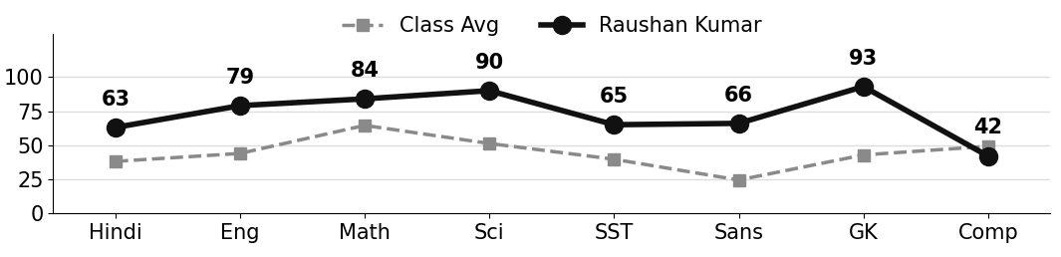
  Class Teacher |  | —— Better Education ★ Brighter Future —— |  | 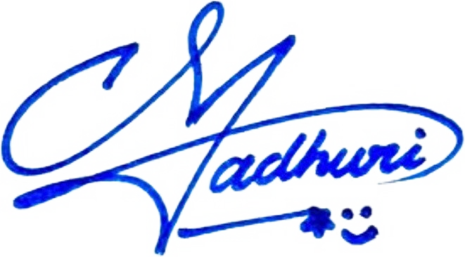  Principal

UNIQUE CENTRAL SCHOOL
KNOWLEDGE ★ CHARACTER ★ PROGRESS
ACADEMIC SESSION : 2025 – 2026
RESULT / MARKSHEET
(P.T.1 – 40 | P.T..2 – 40 | S.A.-1 – 80 | Total – 100)

Class : II | Section : B | Roll No. : 02

Student Information  Student Name : Ajeet Kumar  Father’s Name : Mr. Anil Yadav  Mother’s Name : Mrs. Amita Devi | PHOTO  (Optional) | Result Summary
  Total Marks : | 548 / 800
  Percentage (%) : | 68.50 %
  Overall Grade : | B2
  Result : | PASS
  Rank : | 3

S.No. | Subject | Internal Assessment |  |  |  | Summative  Assessment I  (80 marks) | Total  (100 marks) | Grade
S.No. | Subject | P.T. I | P.T. II | Multiple Assessment | Subject Enrichment | Summative  Assessment I  (80 marks) | Total  (100 marks) | Grade
S.No. | Subject | (5 marks) | (5 marks) | (5 marks) | (5 marks) | Summative  Assessment I  (80 marks) | Total  (100 marks) | Grade
1 | Hindi | 0 | 0 | 2 | 2 | 56 | 60 | C1
2 | English | 0 | 5 | 3 | 3 | 59 | 70 | B2
3 | Maths | 4 | 5 | 4 | 4 | 71 | 88 | A2
4 | Science | 0 | 4 | 3 | 3 | 60 | 70 | B2
5 | Social Sc. | 3 | 3 | 3 | 3 | 53 | 65 | B2
6 | Sans. / Urdu | 2 | 4 | 3 | 3 | 48 | 60 | C1
7 | G.K. | 0 | 4 | 3 | 4 | 78 | 89 | A2
8 | Computer | 3 | 0 | 2 | 2 | 39 | 46 | C2

CO-SCHOLASTIC AREAS |  |  |  |  |  |  | SCALE
Subject | Drawing | Music | Uniform | Sports | Discipline |  | GRADE | A1 | A2 | B1 | B2 | C1 | C2 | D | E
Grade | A | A | B | A | B |  | MARKS RANGE | 91-100 | 81-90 | 71-80 | 61-70 | 51-60 | 41-50 | 31-40 | Below 30
 |  |  |  |  |  |  | CO-SCH. AREAS | GRADE A  Outstanding |  | GRADE B  Very Good |  | GRADE C  Fair

Attendance  Working Days : 132  Present : 107  Absent : 25 | Teacher’s Remark  Ajeet has performed very well and shows good  understanding. A little more practice will bring top  results. |  | Performance Chart (Total /100 : Student vs Class Average)  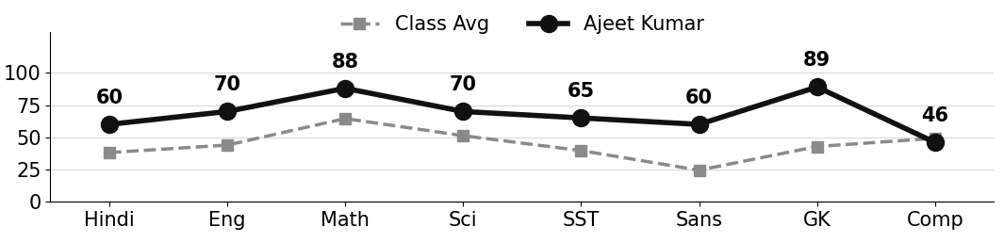
Class Teacher |  | —— Better Education ★ Brighter Future —— |  | Principal

UNIQUE CENTRAL SCHOOL
KNOWLEDGE ★ CHARACTER ★ PROGRESS
ACADEMIC SESSION : 2025 – 2026
RESULT / MARKSHEET
(P.T.1 – 40 | P.T..2 – 40 | S.A.-1 – 80 | Total – 100)

Class : II | Section : B | Roll No. : 03

Student Information  Student Name : Dev Raj Patel  Father’s Name : Mr. Pappu Kumar  Mother’s Name : Mrs. Pooja Kumari | PHOTO  (Optional) | Result Summary
  Total Marks : | 509 / 800
  Percentage (%) : | 63.62 %
  Overall Grade : | B2
  Result : | PASS
  Rank : | 7

S.No. | Subject | Internal Assessment |  |  |  | Summative  Assessment I  (80 marks) | Total  (100 marks) | Grade
S.No. | Subject | P.T. I | P.T. II | Multiple Assessment | Subject Enrichment | Summative  Assessment I  (80 marks) | Total  (100 marks) | Grade
S.No. | Subject | (5 marks) | (5 marks) | (5 marks) | (5 marks) | Summative  Assessment I  (80 marks) | Total  (100 marks) | Grade
1 | Hindi | 5 | 4 | 4 | 3 | 42 | 58 | C1
2 | English | 5 | 5 | 5 | 4 | 66 | 85 | A2
3 | Maths | 2 | 4 | 4 | 4 | 73 | 87 | A2
4 | Science | 4 | 5 | 2 | 1 | 0 | 12 | E
5 | Social Sc. | 3 | 4 | 4 | 4 | 60 | 75 | B1
6 | Sans. / Urdu | 2 | 3 | 3 | 3 | 41 | 52 | C1
7 | G.K. | 5 | 5 | 4 | 4 | 55 | 73 | B1
8 | Computer | 2 | 5 | 3 | 3 | 54 | 67 | B2

CO-SCHOLASTIC AREAS |  |  |  |  |  |  | SCALE
Subject | Drawing | Music | Uniform | Sports | Discipline |  | GRADE | A1 | A2 | B1 | B2 | C1 | C2 | D | E
Grade | A | B | A | B | A |  | MARKS RANGE | 91-100 | 81-90 | 71-80 | 61-70 | 51-60 | 41-50 | 31-40 | Below 30
 |  |  |  |  |  |  | CO-SCH. AREAS | GRADE A  Outstanding |  | GRADE B  Very Good |  | GRADE C  Fair

Attendance  Working Days : 132  Present : 122  Absent : 10 | Teacher’s Remark  Dev is sincere and doing well. More effort will bring  further improvement. Give more time to Science. |  | Performance Chart (Total /100 : Student vs Class Average)  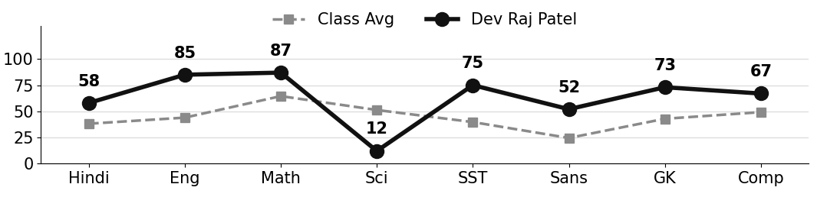
Class Teacher |  | —— Better Education ★ Brighter Future —— |  | Principal

UNIQUE CENTRAL SCHOOL
KNOWLEDGE ★ CHARACTER ★ PROGRESS
ACADEMIC SESSION : 2025 – 2026
RESULT / MARKSHEET
(P.T.1 – 40 | P.T..2 – 40 | S.A.-1 – 80 | Total – 100)

Class : II | Section : B | Roll No. : 04

Student Information  Student Name : Mahi Kumari  Father’s Name : Mr. Amrith Saw  Mother’s Name : Mrs. Lakho Devi | PHOTO  (Optional) | Result Summary
  Total Marks : | 549 / 800
  Percentage (%) : | 68.62 %
  Overall Grade : | B2
  Result : | PASS
  Rank : | 2

S.No. | Subject | Internal Assessment |  |  |  | Summative  Assessment I  (80 marks) | Total  (100 marks) | Grade
S.No. | Subject | P.T. I | P.T. II | Multiple Assessment | Subject Enrichment | Summative  Assessment I  (80 marks) | Total  (100 marks) | Grade
S.No. | Subject | (5 marks) | (5 marks) | (5 marks) | (5 marks) | Summative  Assessment I  (80 marks) | Total  (100 marks) | Grade
1 | Hindi | 4 | 4 | 3 | 3 | 40 | 54 | C1
2 | English | 4 | 5 | 4 | 4 | 63 | 80 | B1
3 | Maths | 3 | 4 | 4 | 4 | 76 | 91 | A1
4 | Science | 2 | 4 | 3 | 3 | 59 | 71 | B1
5 | Social Sc. | 4 | 4 | 4 | 4 | 60 | 76 | B1
6 | Sans. / Urdu | 3 | 4 | 4 | 4 | 70 | 85 | A2
7 | G.K. | 5 | 4 | 2 | 1 | 0 | 12 | E
8 | Computer | 5 | 4 | 4 | 4 | 63 | 80 | B1

CO-SCHOLASTIC AREAS |  |  |  |  |  |  | SCALE
Subject | Drawing | Music | Uniform | Sports | Discipline |  | GRADE | A1 | A2 | B1 | B2 | C1 | C2 | D | E
Grade | A | B | A | A | A |  | MARKS RANGE | 91-100 | 81-90 | 71-80 | 61-70 | 51-60 | 41-50 | 31-40 | Below 30
 |  |  |  |  |  |  | CO-SCH. AREAS | GRADE A  Outstanding |  | GRADE B  Very Good |  | GRADE C  Fair

Attendance  Working Days : 132  Present : 124  Absent : 8 | Teacher’s Remark  Mahi has performed very well and shows good  understanding. A little more practice will bring top  results. |  | Performance Chart (Total /100 : Student vs Class Average)  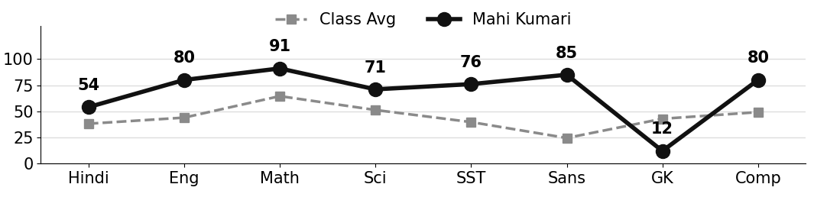
Class Teacher |  | —— Better Education ★ Brighter Future —— |  | Principal

UNIQUE CENTRAL SCHOOL
KNOWLEDGE ★ CHARACTER ★ PROGRESS
ACADEMIC SESSION : 2025 – 2026
RESULT / MARKSHEET
(P.T.1 – 40 | P.T..2 – 40 | S.A.-1 – 80 | Total – 100)

Class : II | Section : B | Roll No. : 05

Student Information  Student Name : Nandani Kumari  Father’s Name : Mr. Munna Prasad  Mother’s Name : Mrs. Priyanka Kumari | PHOTO  (Optional) | Result Summary
  Total Marks : | 544 / 800
  Percentage (%) : | 68.00 %
  Overall Grade : | B2
  Result : | PASS
  Rank : | 5

S.No. | Subject | Internal Assessment |  |  |  | Summative  Assessment I  (80 marks) | Total  (100 marks) | Grade
S.No. | Subject | P.T. I | P.T. II | Multiple Assessment | Subject Enrichment | Summative  Assessment I  (80 marks) | Total  (100 marks) | Grade
S.No. | Subject | (5 marks) | (5 marks) | (5 marks) | (5 marks) | Summative  Assessment I  (80 marks) | Total  (100 marks) | Grade
1 | Hindi | 4 | 2 | 3 | 2 | 34 | 45 | C2
2 | English | 2 | 5 | 4 | 4 | 63 | 78 | B1
3 | Maths | 4 | 5 | 4 | 4 | 63 | 80 | B1
4 | Science | 1 | 2 | 2 | 3 | 55 | 63 | B2
5 | Social Sc. | 3 | 1 | 3 | 3 | 58 | 68 | B2
6 | Sans. / Urdu | 2 | 4 | 3 | 3 | 40 | 52 | C1
7 | G.K. | 2 | 4 | 4 | 4 | 70 | 84 | A2
8 | Computer | 2 | 5 | 4 | 4 | 59 | 74 | B1

CO-SCHOLASTIC AREAS |  |  |  |  |  |  | SCALE
Subject | Drawing | Music | Uniform | Sports | Discipline |  | GRADE | A1 | A2 | B1 | B2 | C1 | C2 | D | E
Grade | B | A | A | A | A |  | MARKS RANGE | 91-100 | 81-90 | 71-80 | 61-70 | 51-60 | 41-50 | 31-40 | Below 30
 |  |  |  |  |  |  | CO-SCH. AREAS | GRADE A  Outstanding |  | GRADE B  Very Good |  | GRADE C  Fair

Attendance  Working Days : 132  Present : 119  Absent : 13 | Teacher’s Remark  Nandani has performed very well and shows good  understanding. A little more practice will bring top  results. |  | Performance Chart (Total /100 : Student vs Class Average)  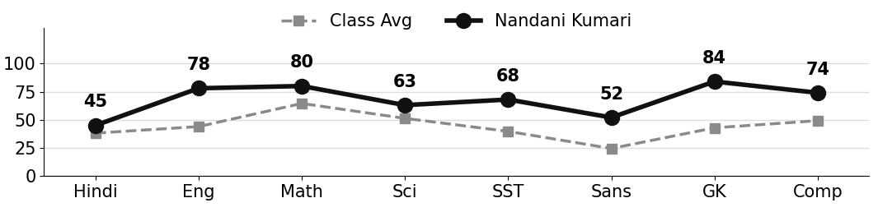
Class Teacher |  | —— Better Education ★ Brighter Future —— |  | Principal

UNIQUE CENTRAL SCHOOL
KNOWLEDGE ★ CHARACTER ★ PROGRESS
ACADEMIC SESSION : 2025 – 2026
RESULT / MARKSHEET
(P.T.1 – 40 | P.T..2 – 40 | S.A.-1 – 80 | Total – 100)

Class : II | Section : B | Roll No. : 06

Student Information  Student Name : Sujeet Kumar  Father’s Name : Mr. Anil Yadav  Mother’s Name : Mrs. Amita Devi | PHOTO  (Optional) | Result Summary
  Total Marks : | 546 / 800
  Percentage (%) : | 68.25 %
  Overall Grade : | B2
  Result : | PASS
  Rank : | 4

S.No. | Subject | Internal Assessment |  |  |  | Summative  Assessment I  (80 marks) | Total  (100 marks) | Grade
S.No. | Subject | P.T. I | P.T. II | Multiple Assessment | Subject Enrichment | Summative  Assessment I  (80 marks) | Total  (100 marks) | Grade
S.No. | Subject | (5 marks) | (5 marks) | (5 marks) | (5 marks) | Summative  Assessment I  (80 marks) | Total  (100 marks) | Grade
1 | Hindi | 5 | 3 | 3 | 3 | 35 | 49 | C2
2 | English | 4 | 5 | 4 | 4 | 65 | 82 | A2
3 | Maths | 3 | 5 | 4 | 4 | 67 | 83 | A2
4 | Science | 2 | 4 | 3 | 4 | 60 | 73 | B1
5 | Social Sc. | 3 | 3 | 3 | 4 | 60 | 73 | B1
6 | Sans. / Urdu | 1 | 4 | 2 | 2 | 22 | 31 | D
7 | G.K. | 5 | 4 | 4 | 4 | 60 | 77 | B1
8 | Computer | 3 | 5 | 4 | 4 | 62 | 78 | B1

CO-SCHOLASTIC AREAS |  |  |  |  |  |  | SCALE
Subject | Drawing | Music | Uniform | Sports | Discipline |  | GRADE | A1 | A2 | B1 | B2 | C1 | C2 | D | E
Grade | A | B | B | A | B |  | MARKS RANGE | 91-100 | 81-90 | 71-80 | 61-70 | 51-60 | 41-50 | 31-40 | Below 30
 |  |  |  |  |  |  | CO-SCH. AREAS | GRADE A  Outstanding |  | GRADE B  Very Good |  | GRADE C  Fair

Attendance  Working Days : 132  Present : 106  Absent : 26 | Teacher’s Remark  Sujeet has performed very well and shows good  understanding. A little more practice will bring top  results. |  | Performance Chart (Total /100 : Student vs Class Average)  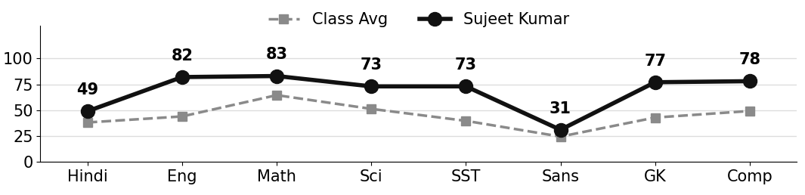
Class Teacher |  | —— Better Education ★ Brighter Future —— |  | Principal

UNIQUE CENTRAL SCHOOL
KNOWLEDGE ★ CHARACTER ★ PROGRESS
ACADEMIC SESSION : 2025 – 2026
RESULT / MARKSHEET
(P.T.1 – 40 | P.T..2 – 40 | S.A.-1 – 80 | Total – 100)

Class : II | Section : B | Roll No. : 07

Student Information  Student Name :  Father’s Name :  Mother’s Name : | PHOTO  (Optional) | Result Summary
  Total Marks :
  Percentage (%) :
  Overall Grade :
  Result :
  Rank :

S.No. | Subject | Internal Assessment |  |  |  | Summative  Assessment I  (80 marks) | Total  (100 marks) | Grade
S.No. | Subject | P.T. I | P.T. II | Multiple Assessment | Subject Enrichment | Summative  Assessment I  (80 marks) | Total  (100 marks) | Grade
S.No. | Subject | (5 marks) | (5 marks) | (5 marks) | (5 marks) | Summative  Assessment I  (80 marks) | Total  (100 marks) | Grade
1 | Hindi
2 | English
3 | Maths
4 | Science
5 | Social Sc.
6 | Sans. / Urdu
7 | G.K.
8 | Computer

CO-SCHOLASTIC AREAS |  |  |  |  |  |  | SCALE
Subject | Drawing | Music | Uniform | Sports | Discipline |  | GRADE | A1 | A2 | B1 | B2 | C1 | C2 | D | E
Grade |  |  |  |  |  |  | MARKS RANGE | 91-100 | 81-90 | 71-80 | 61-70 | 51-60 | 41-50 | 31-40 | Below 30
 |  |  |  |  |  |  | CO-SCH. AREAS | GRADE A  Outstanding |  | GRADE B  Very Good |  | GRADE C  Fair

Attendance  Working Days : 132  Present :  Absent : | Teacher’s Remark |  | Performance Chart (Total /100 : Student vs Class Average)  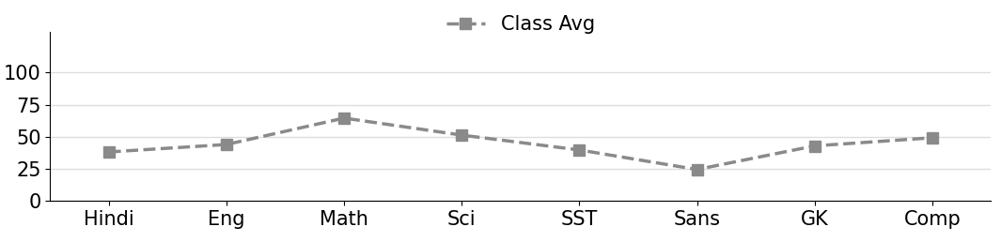
Class Teacher |  | —— Better Education ★ Brighter Future —— |  | Principal

UNIQUE CENTRAL SCHOOL
KNOWLEDGE ★ CHARACTER ★ PROGRESS
ACADEMIC SESSION : 2025 – 2026
RESULT / MARKSHEET
(P.T.1 – 40 | P.T..2 – 40 | S.A.-1 – 80 | Total – 100)

Class : II | Section : B | Roll No. : 08

Student Information  Student Name : Jiya Kumari  Father’s Name : Mr. Shankar Chaudhary  Mother’s Name : Mrs. Rubby Devi | PHOTO  (Optional) | Result Summary
  Total Marks : | 535 / 800
  Percentage (%) : | 66.88 %
  Overall Grade : | B2
  Result : | PASS
  Rank : | 6

S.No. | Subject | Internal Assessment |  |  |  | Summative  Assessment I  (80 marks) | Total  (100 marks) | Grade
S.No. | Subject | P.T. I | P.T. II | Multiple Assessment | Subject Enrichment | Summative  Assessment I  (80 marks) | Total  (100 marks) | Grade
S.No. | Subject | (5 marks) | (5 marks) | (5 marks) | (5 marks) | Summative  Assessment I  (80 marks) | Total  (100 marks) | Grade
1 | Hindi | 3 | 2 | 2 | 2 | 30 | 39 | D
2 | English | 2 | 4 | 4 | 4 | 69 | 83 | A2
3 | Maths | 4 | 5 | 4 | 4 | 65 | 82 | A2
4 | Science | 2 | 1 | 3 | 4 | 71 | 81 | A2
5 | Social Sc. | 2 | 1 | 2 | 2 | 33 | 40 | D
6 | Sans. / Urdu | 1 | 3 | 2 | 2 | 40 | 48 | C2
7 | G.K. | 2 | 4 | 4 | 4 | 80 | 94 | A1
8 | Computer | 2 | 5 | 3 | 3 | 55 | 68 | B2

CO-SCHOLASTIC AREAS |  |  |  |  |  |  | SCALE
Subject | Drawing | Music | Uniform | Sports | Discipline |  | GRADE | A1 | A2 | B1 | B2 | C1 | C2 | D | E
Grade | B | A | A | A | A |  | MARKS RANGE | 91-100 | 81-90 | 71-80 | 61-70 | 51-60 | 41-50 | 31-40 | Below 30
 |  |  |  |  |  |  | CO-SCH. AREAS | GRADE A  Outstanding |  | GRADE B  Very Good |  | GRADE C  Fair

Attendance  Working Days : 132  Present : 119  Absent : 13 | Teacher’s Remark  Jiya has performed very well and shows good  understanding. A little more practice will bring top  results. |  | Performance Chart (Total /100 : Student vs Class Average)  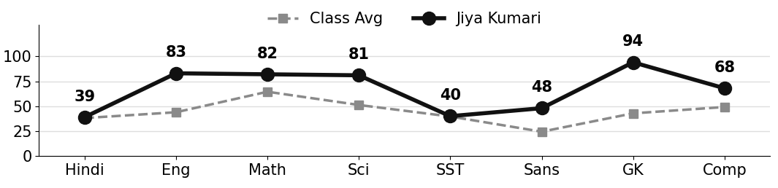
Class Teacher |  | —— Better Education ★ Brighter Future —— |  | Principal

UNIQUE CENTRAL SCHOOL
KNOWLEDGE ★ CHARACTER ★ PROGRESS
ACADEMIC SESSION : 2025 – 2026
RESULT / MARKSHEET
(P.T.1 – 40 | P.T..2 – 40 | S.A.-1 – 80 | Total – 100)

Class : II | Section : B | Roll No. : 09

Student Information  Student Name : Aman Kumar  Father’s Name : Mr. Chunchun Yadav  Mother’s Name : Mrs. Reena Devi | PHOTO  (Optional) | Result Summary
  Total Marks : | 397 / 800
  Percentage (%) : | 49.62 %
  Overall Grade : | C2
  Result : | PASS
  Rank : | 13

S.No. | Subject | Internal Assessment |  |  |  | Summative  Assessment I  (80 marks) | Total  (100 marks) | Grade
S.No. | Subject | P.T. I | P.T. II | Multiple Assessment | Subject Enrichment | Summative  Assessment I  (80 marks) | Total  (100 marks) | Grade
S.No. | Subject | (5 marks) | (5 marks) | (5 marks) | (5 marks) | Summative  Assessment I  (80 marks) | Total  (100 marks) | Grade
1 | Hindi | 5 | 3 | 3 | 3 | 30 | 44 | C2
2 | English | 4 | 4 | 4 | 4 | 54 | 70 | B2
3 | Maths | 5 | 4 | 4 | 4 | 63 | 80 | B1
4 | Science | 2 | 2 | 3 | 3 | 50 | 60 | C1
5 | Social Sc. | 4 | 2 | 3 | 3 | 45 | 57 | C1
6 | Sans. / Urdu | 3 | 3 | 2 | 1 | 10 | 19 | E
7 | G.K. | 2 | 2 | 1 | 1 | 12 | 18 | E
8 | Computer | 2 | 2 | 2 | 2 | 41 | 49 | C2

CO-SCHOLASTIC AREAS |  |  |  |  |  |  | SCALE
Subject | Drawing | Music | Uniform | Sports | Discipline |  | GRADE | A1 | A2 | B1 | B2 | C1 | C2 | D | E
Grade | B | C | A | B | A |  | MARKS RANGE | 91-100 | 81-90 | 71-80 | 61-70 | 51-60 | 41-50 | 31-40 | Below 30
 |  |  |  |  |  |  | CO-SCH. AREAS | GRADE A  Outstanding |  | GRADE B  Very Good |  | GRADE C  Fair

Attendance  Working Days : 132  Present : 128  Absent : 4 | Teacher’s Remark  Aman has shown good progress. Regular practice and  revision will give better results. Give more time to  G.K.. |  | Performance Chart (Total /100 : Student vs Class Average)  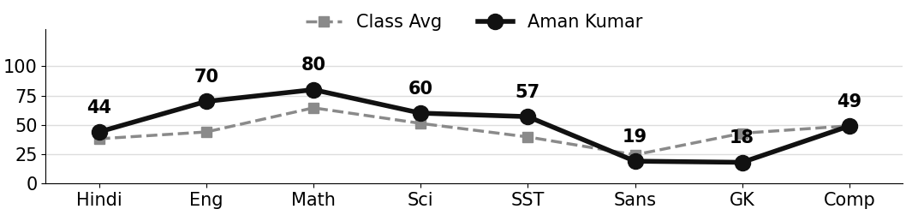
Class Teacher |  | —— Better Education ★ Brighter Future —— |  | Principal

UNIQUE CENTRAL SCHOOL
KNOWLEDGE ★ CHARACTER ★ PROGRESS
ACADEMIC SESSION : 2025 – 2026
RESULT / MARKSHEET
(P.T.1 – 40 | P.T..2 – 40 | S.A.-1 – 80 | Total – 100)

Class : II | Section : B | Roll No. : 10

Student Information  Student Name : Satyam Kumar  Father’s Name : Mr. Sanjay Kumar  Mother’s Name : Mrs. Rita Kumari | PHOTO  (Optional) | Result Summary
  Total Marks : | 407 / 800
  Percentage (%) : | 50.88 %
  Overall Grade : | C2
  Result : | PASS
  Rank : | 11

S.No. | Subject | Internal Assessment |  |  |  | Summative  Assessment I  (80 marks) | Total  (100 marks) | Grade
S.No. | Subject | P.T. I | P.T. II | Multiple Assessment | Subject Enrichment | Summative  Assessment I  (80 marks) | Total  (100 marks) | Grade
S.No. | Subject | (5 marks) | (5 marks) | (5 marks) | (5 marks) | Summative  Assessment I  (80 marks) | Total  (100 marks) | Grade
1 | Hindi | 3 | 3 | 3 | 2 | 35 | 46 | C2
2 | English | 2 | 3 | 3 | 3 | 40 | 51 | C1
3 | Maths | 3 | 3 | 4 | 4 | 64 | 78 | B1
4 | Science | 1 | 3 | 2 | 2 | 41 | 49 | C2
5 | Social Sc. | 2 | 3 | 2 | 2 | 35 | 44 | C2
6 | Sans. / Urdu | 1 | 2 | 1 | 1 | 16 | 21 | E
7 | G.K. | 3 | 3 | 3 | 3 | 45 | 57 | C1
8 | Computer | 2 | 5 | 3 | 3 | 48 | 61 | B2

CO-SCHOLASTIC AREAS |  |  |  |  |  |  | SCALE
Subject | Drawing | Music | Uniform | Sports | Discipline |  | GRADE | A1 | A2 | B1 | B2 | C1 | C2 | D | E
Grade | B | C | B | B | B |  | MARKS RANGE | 91-100 | 81-90 | 71-80 | 61-70 | 51-60 | 41-50 | 31-40 | Below 30
 |  |  |  |  |  |  | CO-SCH. AREAS | GRADE A  Outstanding |  | GRADE B  Very Good |  | GRADE C  Fair

Attendance  Working Days : 132  Present : 113  Absent : 19 | Teacher’s Remark  Satyam has shown good progress. Regular practice and  revision will give better results. Give more time to  Sanskrit. |  | Performance Chart (Total /100 : Student vs Class Average)  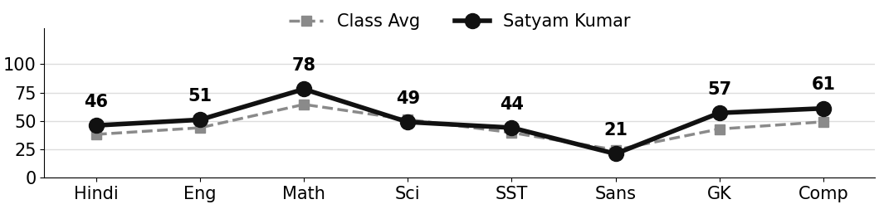
Class Teacher |  | —— Better Education ★ Brighter Future —— |  | Principal

UNIQUE CENTRAL SCHOOL
KNOWLEDGE ★ CHARACTER ★ PROGRESS
ACADEMIC SESSION : 2025 – 2026
RESULT / MARKSHEET
(P.T.1 – 40 | P.T..2 – 40 | S.A.-1 – 80 | Total – 100)

Class : II | Section : B | Roll No. : 11

Student Information  Student Name : Banti Kumar  Father’s Name : Mr. Bijendra Kumar  Mother’s Name : Mrs. Anita Devi | PHOTO  (Optional) | Result Summary
  Total Marks : | 317 / 800
  Percentage (%) : | 39.62 %
  Overall Grade : | D
  Result : | PASS
  Rank : | 17

S.No. | Subject | Internal Assessment |  |  |  | Summative  Assessment I  (80 marks) | Total  (100 marks) | Grade
S.No. | Subject | P.T. I | P.T. II | Multiple Assessment | Subject Enrichment | Summative  Assessment I  (80 marks) | Total  (100 marks) | Grade
S.No. | Subject | (5 marks) | (5 marks) | (5 marks) | (5 marks) | Summative  Assessment I  (80 marks) | Total  (100 marks) | Grade
1 | Hindi | 4 | 3 | 3 | 2 | 30 | 42 | C2
2 | English | 3 | 3 | 3 | 2 | 33 | 44 | C2
3 | Maths | 4 | 3 | 3 | 3 | 40 | 53 | C1
4 | Science | 2 | 1 | 2 | 3 | 53 | 61 | B2
5 | Social Sc. | 2 | 3 | 1 | 1 | 0 | 7 | E
6 | Sans. / Urdu | 2 | 4 | 2 | 2 | 30 | 40 | D
7 | G.K. | 4 | 3 | 2 | 2 | 12 | 23 | E
8 | Computer | 3 | 4 | 3 | 3 | 34 | 47 | C2

CO-SCHOLASTIC AREAS |  |  |  |  |  |  | SCALE
Subject | Drawing | Music | Uniform | Sports | Discipline |  | GRADE | A1 | A2 | B1 | B2 | C1 | C2 | D | E
Grade | B | C | A | C | B |  | MARKS RANGE | 91-100 | 81-90 | 71-80 | 61-70 | 51-60 | 41-50 | 31-40 | Below 30
 |  |  |  |  |  |  | CO-SCH. AREAS | GRADE A  Outstanding |  | GRADE B  Very Good |  | GRADE C  Fair

Attendance  Working Days : 132  Present : 121  Absent : 11 | Teacher’s Remark  Banti is making steady effort but needs more practice  and regular revision. Give more time to Social  Science. |  | Performance Chart (Total /100 : Student vs Class Average)  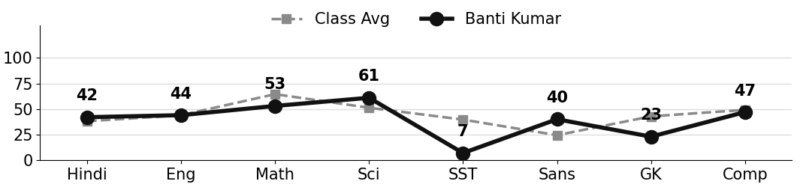
Class Teacher |  | —— Better Education ★ Brighter Future —— |  | Principal

UNIQUE CENTRAL SCHOOL
KNOWLEDGE ★ CHARACTER ★ PROGRESS
ACADEMIC SESSION : 2025 – 2026
RESULT / MARKSHEET
(P.T.1 – 40 | P.T..2 – 40 | S.A.-1 – 80 | Total – 100)

Class : II | Section : B | Roll No. : 12

Student Information  Student Name : Ankit Kumar  Father’s Name : Mr. Sikendra Kumar  Mother’s Name : Mrs. Sunita Devi | PHOTO  (Optional) | Result Summary
  Total Marks : | 419 / 800
  Percentage (%) : | 52.38 %
  Overall Grade : | C1
  Result : | PASS
  Rank : | 9

S.No. | Subject | Internal Assessment |  |  |  | Summative  Assessment I  (80 marks) | Total  (100 marks) | Grade
S.No. | Subject | P.T. I | P.T. II | Multiple Assessment | Subject Enrichment | Summative  Assessment I  (80 marks) | Total  (100 marks) | Grade
S.No. | Subject | (5 marks) | (5 marks) | (5 marks) | (5 marks) | Summative  Assessment I  (80 marks) | Total  (100 marks) | Grade
1 | Hindi | 3 | 0 | 2 | 3 | 49 | 57 | C1
2 | English | 1 | 4 | 2 | 2 | 26 | 35 | D
3 | Maths | 4 | 0 | 3 | 3 | 62 | 72 | B1
4 | Science | 3 | 4 | 4 | 4 | 57 | 72 | B1
5 | Social Sc. | 2 | 3 | 2 | 2 | 30 | 39 | D
6 | Sans. / Urdu | 1 | 4 | 2 | 2 | 29 | 38 | D
7 | G.K. | 4 | 3 | 3 | 3 | 40 | 53 | C1
8 | Computer | 2 | 0 | 2 | 2 | 47 | 53 | C1

CO-SCHOLASTIC AREAS |  |  |  |  |  |  | SCALE
Subject | Drawing | Music | Uniform | Sports | Discipline |  | GRADE | A1 | A2 | B1 | B2 | C1 | C2 | D | E
Grade | B | B | B | B | B |  | MARKS RANGE | 91-100 | 81-90 | 71-80 | 61-70 | 51-60 | 41-50 | 31-40 | Below 30
 |  |  |  |  |  |  | CO-SCH. AREAS | GRADE A  Outstanding |  | GRADE B  Very Good |  | GRADE C  Fair

Attendance  Working Days : 132  Present : 107  Absent : 25 | Teacher’s Remark  Ankit has shown good progress. Regular practice and  revision will give better results. Give more time to  English. |  | Performance Chart (Total /100 : Student vs Class Average)  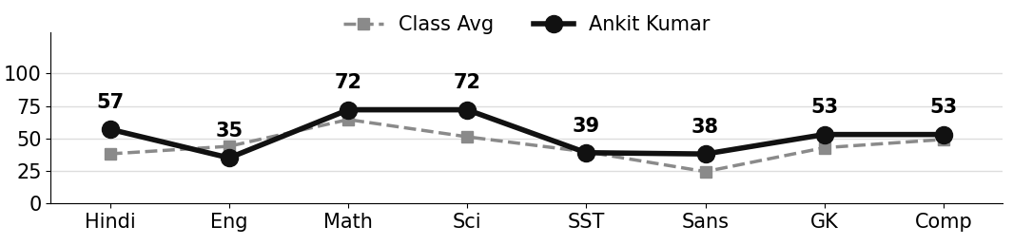
Class Teacher |  | —— Better Education ★ Brighter Future —— |  | Principal

UNIQUE CENTRAL SCHOOL
KNOWLEDGE ★ CHARACTER ★ PROGRESS
ACADEMIC SESSION : 2025 – 2026
RESULT / MARKSHEET
(P.T.1 – 40 | P.T..2 – 40 | S.A.-1 – 80 | Total – 100)

Class : II | Section : B | Roll No. : 13

Student Information  Student Name : Shubham Kumar  Father’s Name : Mr. Sunil Kumar  Mother’s Name : Mrs. Rinki Devi | PHOTO  (Optional) | Result Summary
  Total Marks : | 265 / 800
  Percentage (%) : | 33.12 %
  Overall Grade : | D
  Result : | PASS
  Rank : | 21

S.No. | Subject | Internal Assessment |  |  |  | Summative  Assessment I  (80 marks) | Total  (100 marks) | Grade
S.No. | Subject | P.T. I | P.T. II | Multiple Assessment | Subject Enrichment | Summative  Assessment I  (80 marks) | Total  (100 marks) | Grade
S.No. | Subject | (5 marks) | (5 marks) | (5 marks) | (5 marks) | Summative  Assessment I  (80 marks) | Total  (100 marks) | Grade
1 | Hindi | 2 | 0 | 2 | 2 | 36 | 42 | C2
2 | English | 0 | 4 | 2 | 2 | 37 | 45 | C2
3 | Maths | 3 | 4 | 3 | 3 | 47 | 60 | C1
4 | Science | 2 | 2 | 2 | 2 | 30 | 38 | D
5 | Social Sc. | 3 | 2 | 2 | 2 | 35 | 44 | C2
6 | Sans. / Urdu | 1 | 3 | 1 | 1 | 0 | 6 | E
7 | G.K. | 0 | 3 | 1 | 1 | 0 | 5 | E
8 | Computer | 2 | 0 | 1 | 1 | 21 | 25 | E

CO-SCHOLASTIC AREAS |  |  |  |  |  |  | SCALE
Subject | Drawing | Music | Uniform | Sports | Discipline |  | GRADE | A1 | A2 | B1 | B2 | C1 | C2 | D | E
Grade | B | C | B | C | B |  | MARKS RANGE | 91-100 | 81-90 | 71-80 | 61-70 | 51-60 | 41-50 | 31-40 | Below 30
 |  |  |  |  |  |  | CO-SCH. AREAS | GRADE A  Outstanding |  | GRADE B  Very Good |  | GRADE C  Fair

Attendance  Working Days : 132  Present : 111  Absent : 21 | Teacher’s Remark  Shubham is making steady effort but needs more  practice and regular revision. Give more time to G.K.. |  | Performance Chart (Total /100 : Student vs Class Average)  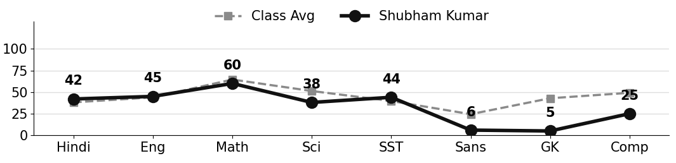
Class Teacher |  | —— Better Education ★ Brighter Future —— |  | Principal

UNIQUE CENTRAL SCHOOL
KNOWLEDGE ★ CHARACTER ★ PROGRESS
ACADEMIC SESSION : 2025 – 2026
RESULT / MARKSHEET
(P.T.1 – 40 | P.T..2 – 40 | S.A.-1 – 80 | Total – 100)

Class : II | Section : B | Roll No. : 14

Student Information  Student Name : Sonakshi Kumari  Father’s Name : Mr. Santosh Prasad Keshari  Mother’s Name : Mrs. Soni Devi | PHOTO  (Optional) | Result Summary
  Total Marks : | 316 / 800
  Percentage (%) : | 39.50 %
  Overall Grade : | D
  Result : | PASS
  Rank : | 18

S.No. | Subject | Internal Assessment |  |  |  | Summative  Assessment I  (80 marks) | Total  (100 marks) | Grade
S.No. | Subject | P.T. I | P.T. II | Multiple Assessment | Subject Enrichment | Summative  Assessment I  (80 marks) | Total  (100 marks) | Grade
S.No. | Subject | (5 marks) | (5 marks) | (5 marks) | (5 marks) | Summative  Assessment I  (80 marks) | Total  (100 marks) | Grade
1 | Hindi | 4 | 0 | 2 | 2 | 35 | 43 | C2
2 | English | 2 | 4 | 3 | 3 | 42 | 54 | C1
3 | Maths | 3 | 5 | 3 | 3 | 38 | 52 | C1
4 | Science | 0 | 2 | 2 | 2 | 40 | 46 | C2
5 | Social Sc. | 1 | 1 | 1 | 1 | 25 | 29 | E
6 | Sans. / Urdu | 2 | 2 | 1 | 1 | 9 | 15 | E
7 | G.K. | 4 | 3 | 2 | 2 | 22 | 33 | D
8 | Computer | 2 | 0 | 2 | 2 | 38 | 44 | C2

CO-SCHOLASTIC AREAS |  |  |  |  |  |  | SCALE
Subject | Drawing | Music | Uniform | Sports | Discipline |  | GRADE | A1 | A2 | B1 | B2 | C1 | C2 | D | E
Grade | B | C | A | C | B |  | MARKS RANGE | 91-100 | 81-90 | 71-80 | 61-70 | 51-60 | 41-50 | 31-40 | Below 30
 |  |  |  |  |  |  | CO-SCH. AREAS | GRADE A  Outstanding |  | GRADE B  Very Good |  | GRADE C  Fair

Attendance  Working Days : 132  Present : 126  Absent : 6 | Teacher’s Remark  Sonakshi is making steady effort but needs more  practice and regular revision. Give more time to  Sanskrit. |  | Performance Chart (Total /100 : Student vs Class Average)  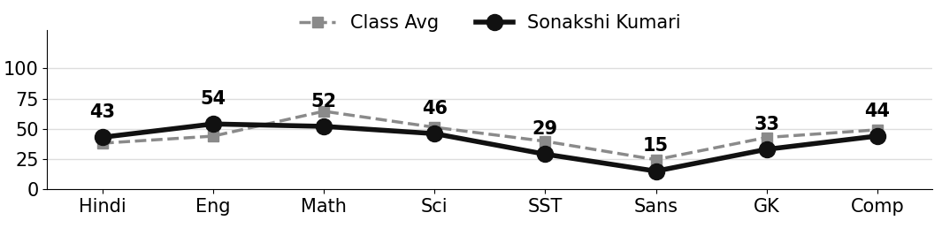
Class Teacher |  | —— Better Education ★ Brighter Future —— |  | Principal

UNIQUE CENTRAL SCHOOL
KNOWLEDGE ★ CHARACTER ★ PROGRESS
ACADEMIC SESSION : 2025 – 2026
RESULT / MARKSHEET
(P.T.1 – 40 | P.T..2 – 40 | S.A.-1 – 80 | Total – 100)

Class : II | Section : B | Roll No. : 15

Student Information  Student Name : Ashik Raj  Father’s Name : Mr. Ashok Kumar  Mother’s Name : Mrs. Rubby Devi | PHOTO  (Optional) | Result Summary
  Total Marks : | 407 / 800
  Percentage (%) : | 50.88 %
  Overall Grade : | C2
  Result : | PASS
  Rank : | 11

S.No. | Subject | Internal Assessment |  |  |  | Summative  Assessment I  (80 marks) | Total  (100 marks) | Grade
S.No. | Subject | P.T. I | P.T. II | Multiple Assessment | Subject Enrichment | Summative  Assessment I  (80 marks) | Total  (100 marks) | Grade
S.No. | Subject | (5 marks) | (5 marks) | (5 marks) | (5 marks) | Summative  Assessment I  (80 marks) | Total  (100 marks) | Grade
1 | Hindi | 4 | 2 | 3 | 3 | 42 | 54 | C1
2 | English | 3 | 4 | 3 | 3 | 50 | 63 | B2
3 | Maths | 3 | 3 | 3 | 3 | 58 | 70 | B2
4 | Science | 2 | 1 | 2 | 3 | 55 | 63 | B2
5 | Social Sc. | 2 | 2 | 2 | 2 | 40 | 48 | C2
6 | Sans. / Urdu | 2 | 3 | 1 | 1 | 0 | 7 | E
7 | G.K. | 2 | 3 | 3 | 3 | 40 | 51 | C1
8 | Computer | 1 | 2 | 2 | 2 | 44 | 51 | C1

CO-SCHOLASTIC AREAS |  |  |  |  |  |  | SCALE
Subject | Drawing | Music | Uniform | Sports | Discipline |  | GRADE | A1 | A2 | B1 | B2 | C1 | C2 | D | E
Grade | B | C | A | B | A |  | MARKS RANGE | 91-100 | 81-90 | 71-80 | 61-70 | 51-60 | 41-50 | 31-40 | Below 30
 |  |  |  |  |  |  | CO-SCH. AREAS | GRADE A  Outstanding |  | GRADE B  Very Good |  | GRADE C  Fair

Attendance  Working Days : 132  Present : 121  Absent : 11 | Teacher’s Remark  Ashik has shown good progress. Regular practice and  revision will give better results. Give more time to  Sanskrit. |  | Performance Chart (Total /100 : Student vs Class Average)  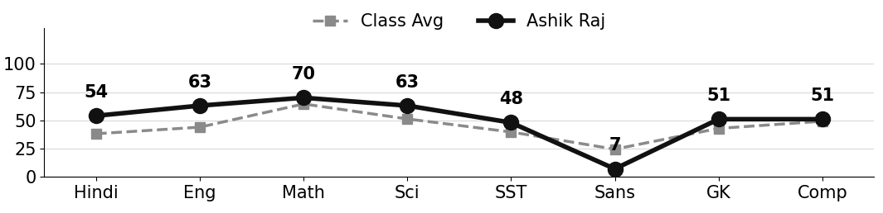
Class Teacher |  | —— Better Education ★ Brighter Future —— |  | Principal

UNIQUE CENTRAL SCHOOL
KNOWLEDGE ★ CHARACTER ★ PROGRESS
ACADEMIC SESSION : 2025 – 2026
RESULT / MARKSHEET
(P.T.1 – 40 | P.T..2 – 40 | S.A.-1 – 80 | Total – 100)

Class : II | Section : B | Roll No. : 16

Student Information  Student Name : Priya Kumari  Father’s Name : Mr. Ramjee Saw  Mother’s Name : Mrs. Jyanti Devi | PHOTO  (Optional) | Result Summary
  Total Marks : | 340 / 800
  Percentage (%) : | 42.50 %
  Overall Grade : | C2
  Result : | PASS
  Rank : | 16

S.No. | Subject | Internal Assessment |  |  |  | Summative  Assessment I  (80 marks) | Total  (100 marks) | Grade
S.No. | Subject | P.T. I | P.T. II | Multiple Assessment | Subject Enrichment | Summative  Assessment I  (80 marks) | Total  (100 marks) | Grade
S.No. | Subject | (5 marks) | (5 marks) | (5 marks) | (5 marks) | Summative  Assessment I  (80 marks) | Total  (100 marks) | Grade
1 | Hindi | 3 | 3 | 2 | 2 | 28 | 38 | D
2 | English | 3 | 4 | 3 | 3 | 39 | 52 | C1
3 | Maths | 5 | 4 | 4 | 3 | 49 | 65 | B2
4 | Science | 1 | 1 | 2 | 3 | 62 | 69 | B2
5 | Social Sc. | 2 | 4 | 2 | 2 | 24 | 34 | D
6 | Sans. / Urdu | 2 | 3 | 1 | 1 | 0 | 7 | E
7 | G.K. | 3 | 3 | 2 | 2 | 18 | 28 | E
8 | Computer | 2 | 5 | 3 | 3 | 34 | 47 | C2

CO-SCHOLASTIC AREAS |  |  |  |  |  |  | SCALE
Subject | Drawing | Music | Uniform | Sports | Discipline |  | GRADE | A1 | A2 | B1 | B2 | C1 | C2 | D | E
Grade | B | C | A | B | A |  | MARKS RANGE | 91-100 | 81-90 | 71-80 | 61-70 | 51-60 | 41-50 | 31-40 | Below 30
 |  |  |  |  |  |  | CO-SCH. AREAS | GRADE A  Outstanding |  | GRADE B  Very Good |  | GRADE C  Fair

Attendance  Working Days : 132  Present : 119  Absent : 13 | Teacher’s Remark  Good effort by Priya. Needs regular practice to reach  a higher level. Give more time to Sanskrit. |  | Performance Chart (Total /100 : Student vs Class Average)  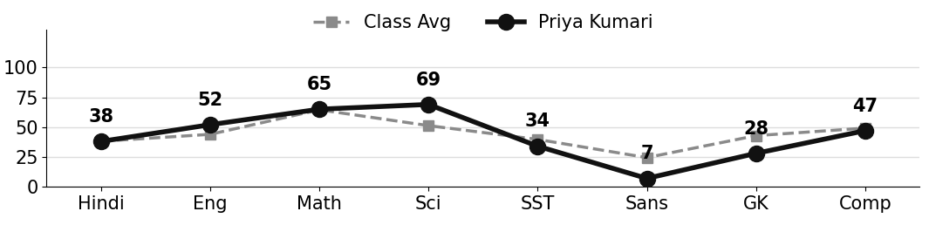
Class Teacher |  | —— Better Education ★ Brighter Future —— |  | Principal

UNIQUE CENTRAL SCHOOL
KNOWLEDGE ★ CHARACTER ★ PROGRESS
ACADEMIC SESSION : 2025 – 2026
RESULT / MARKSHEET
(P.T.1 – 40 | P.T..2 – 40 | S.A.-1 – 80 | Total – 100)

Class : II | Section : B | Roll No. : 17

Student Information  Student Name :  Father’s Name :  Mother’s Name : | PHOTO  (Optional) | Result Summary
  Total Marks :
  Percentage (%) :
  Overall Grade :
  Result :
  Rank :

S.No. | Subject | Internal Assessment |  |  |  | Summative  Assessment I  (80 marks) | Total  (100 marks) | Grade
S.No. | Subject | P.T. I | P.T. II | Multiple Assessment | Subject Enrichment | Summative  Assessment I  (80 marks) | Total  (100 marks) | Grade
S.No. | Subject | (5 marks) | (5 marks) | (5 marks) | (5 marks) | Summative  Assessment I  (80 marks) | Total  (100 marks) | Grade
1 | Hindi
2 | English
3 | Maths
4 | Science
5 | Social Sc.
6 | Sans. / Urdu
7 | G.K.
8 | Computer

CO-SCHOLASTIC AREAS |  |  |  |  |  |  | SCALE
Subject | Drawing | Music | Uniform | Sports | Discipline |  | GRADE | A1 | A2 | B1 | B2 | C1 | C2 | D | E
Grade |  |  |  |  |  |  | MARKS RANGE | 91-100 | 81-90 | 71-80 | 61-70 | 51-60 | 41-50 | 31-40 | Below 30
 |  |  |  |  |  |  | CO-SCH. AREAS | GRADE A  Outstanding |  | GRADE B  Very Good |  | GRADE C  Fair

Attendance  Working Days : 132  Present :  Absent : | Teacher’s Remark |  | Performance Chart (Total /100 : Student vs Class Average)
Class Teacher |  | —— Better Education ★ Brighter Future —— |  | Principal

UNIQUE CENTRAL SCHOOL
KNOWLEDGE ★ CHARACTER ★ PROGRESS
ACADEMIC SESSION : 2025 – 2026
RESULT / MARKSHEET
(P.T.1 – 40 | P.T..2 – 40 | S.A.-1 – 80 | Total – 100)

Class : II | Section : B | Roll No. : 18

Student Information  Student Name : Jitu Kumar  Father’s Name : Mr. Nagendra Kumar  Mother’s Name : Mrs. Punam Devi | PHOTO  (Optional) | Result Summary
  Total Marks : | 459 / 800
  Percentage (%) : | 57.38 %
  Overall Grade : | C1
  Result : | PASS
  Rank : | 8

S.No. | Subject | Internal Assessment |  |  |  | Summative  Assessment I  (80 marks) | Total  (100 marks) | Grade
S.No. | Subject | P.T. I | P.T. II | Multiple Assessment | Subject Enrichment | Summative  Assessment I  (80 marks) | Total  (100 marks) | Grade
S.No. | Subject | (5 marks) | (5 marks) | (5 marks) | (5 marks) | Summative  Assessment I  (80 marks) | Total  (100 marks) | Grade
1 | Hindi | 2 | 3 | 2 | 2 | 26 | 35 | D
2 | English | 1 | 4 | 3 | 3 | 45 | 56 | C1
3 | Maths | 5 | 3 | 4 | 4 | 63 | 79 | B1
4 | Science | 1 | 1 | 2 | 3 | 61 | 68 | B2
5 | Social Sc. | 2 | 2 | 2 | 2 | 34 | 42 | C2
6 | Sans. / Urdu | 2 | 3 | 3 | 3 | 45 | 56 | C1
7 | G.K. | 1 | 3 | 3 | 3 | 57 | 67 | B2
8 | Computer | 2 | 5 | 3 | 3 | 43 | 56 | C1

CO-SCHOLASTIC AREAS |  |  |  |  |  |  | SCALE
Subject | Drawing | Music | Uniform | Sports | Discipline |  | GRADE | A1 | A2 | B1 | B2 | C1 | C2 | D | E
Grade | B | B | A | B | A |  | MARKS RANGE | 91-100 | 81-90 | 71-80 | 61-70 | 51-60 | 41-50 | 31-40 | Below 30
 |  |  |  |  |  |  | CO-SCH. AREAS | GRADE A  Outstanding |  | GRADE B  Very Good |  | GRADE C  Fair

Attendance  Working Days : 132  Present : 118  Absent : 14 | Teacher’s Remark  Jitu is sincere and doing well. More effort will bring  further improvement. Give more time to Hindi. |  | Performance Chart (Total /100 : Student vs Class Average)  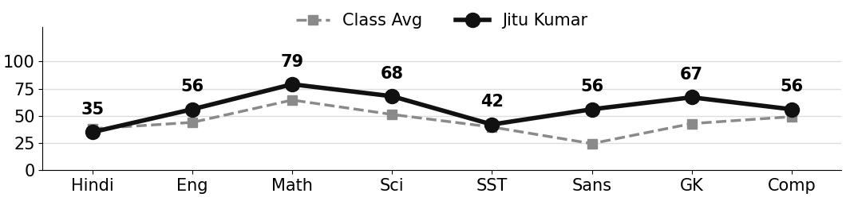
Class Teacher |  | —— Better Education ★ Brighter Future —— |  | Principal

UNIQUE CENTRAL SCHOOL
KNOWLEDGE ★ CHARACTER ★ PROGRESS
ACADEMIC SESSION : 2025 – 2026
RESULT / MARKSHEET
(P.T.1 – 40 | P.T..2 – 40 | S.A.-1 – 80 | Total – 100)

Class : II | Section : B | Roll No. : 19

Student Information  Student Name : Manish Raj  Father’s Name : Mr. Soharai Yadav  Mother’s Name : Mrs. Murti Devi | PHOTO  (Optional) | Result Summary
  Total Marks : | 415 / 800
  Percentage (%) : | 51.88 %
  Overall Grade : | C1
  Result : | PASS
  Rank : | 10

S.No. | Subject | Internal Assessment |  |  |  | Summative  Assessment I  (80 marks) | Total  (100 marks) | Grade
S.No. | Subject | P.T. I | P.T. II | Multiple Assessment | Subject Enrichment | Summative  Assessment I  (80 marks) | Total  (100 marks) | Grade
S.No. | Subject | (5 marks) | (5 marks) | (5 marks) | (5 marks) | Summative  Assessment I  (80 marks) | Total  (100 marks) | Grade
1 | Hindi | 4 | 3 | 3 | 3 | 36 | 49 | C2
2 | English | 1 | 4 | 2 | 2 | 22 | 31 | D
3 | Maths | 5 | 4 | 4 | 4 | 58 | 75 | B1
4 | Science | 2 | 1 | 2 | 3 | 52 | 60 | C1
5 | Social Sc. | 1 | 3 | 2 | 2 | 36 | 44 | C2
6 | Sans. / Urdu | 1 | 3 | 1 | 1 | 0 | 6 | E
7 | G.K. | 2 | 3 | 4 | 4 | 72 | 85 | A2
8 | Computer | 5 | 4 | 4 | 3 | 49 | 65 | B2

CO-SCHOLASTIC AREAS |  |  |  |  |  |  | SCALE
Subject | Drawing | Music | Uniform | Sports | Discipline |  | GRADE | A1 | A2 | B1 | B2 | C1 | C2 | D | E
Grade | B | B | C | B | C |  | MARKS RANGE | 91-100 | 81-90 | 71-80 | 61-70 | 51-60 | 41-50 | 31-40 | Below 30
 |  |  |  |  |  |  | CO-SCH. AREAS | GRADE A  Outstanding |  | GRADE B  Very Good |  | GRADE C  Fair

Attendance  Working Days : 132  Present : 91  Absent : 41 | Teacher’s Remark  Manish has shown good progress. Regular practice and  revision will give better results. Give more time to  Sanskrit. |  | Performance Chart (Total /100 : Student vs Class Average)  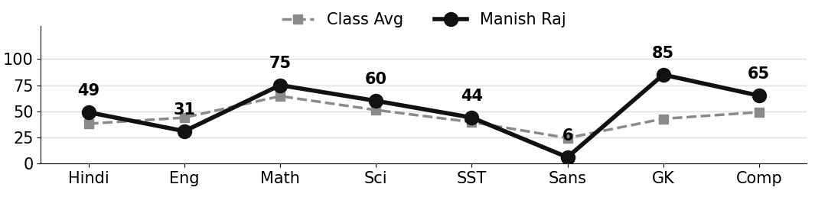
Class Teacher |  | —— Better Education ★ Brighter Future —— |  | Principal

UNIQUE CENTRAL SCHOOL
KNOWLEDGE ★ CHARACTER ★ PROGRESS
ACADEMIC SESSION : 2025 – 2026
RESULT / MARKSHEET
(P.T.1 – 40 | P.T..2 – 40 | S.A.-1 – 80 | Total – 100)

Class : II | Section : B | Roll No. : 20

Student Information  Student Name :  Father’s Name :  Mother’s Name : | PHOTO  (Optional) | Result Summary
  Total Marks :
  Percentage (%) :
  Overall Grade :
  Result :
  Rank :

S.No. | Subject | Internal Assessment |  |  |  | Summative  Assessment I  (80 marks) | Total  (100 marks) | Grade
S.No. | Subject | P.T. I | P.T. II | Multiple Assessment | Subject Enrichment | Summative  Assessment I  (80 marks) | Total  (100 marks) | Grade
S.No. | Subject | (5 marks) | (5 marks) | (5 marks) | (5 marks) | Summative  Assessment I  (80 marks) | Total  (100 marks) | Grade
1 | Hindi
2 | English
3 | Maths
4 | Science
5 | Social Sc.
6 | Sans. / Urdu
7 | G.K.
8 | Computer

CO-SCHOLASTIC AREAS |  |  |  |  |  |  | SCALE
Subject | Drawing | Music | Uniform | Sports | Discipline |  | GRADE | A1 | A2 | B1 | B2 | C1 | C2 | D | E
Grade |  |  |  |  |  |  | MARKS RANGE | 91-100 | 81-90 | 71-80 | 61-70 | 51-60 | 41-50 | 31-40 | Below 30
 |  |  |  |  |  |  | CO-SCH. AREAS | GRADE A  Outstanding |  | GRADE B  Very Good |  | GRADE C  Fair

Attendance  Working Days : 132  Present :  Absent : | Teacher’s Remark |  | Performance Chart (Total /100 : Student vs Class Average)
Class Teacher |  | —— Better Education ★ Brighter Future —— |  | Principal

UNIQUE CENTRAL SCHOOL
KNOWLEDGE ★ CHARACTER ★ PROGRESS
ACADEMIC SESSION : 2025 – 2026
RESULT / MARKSHEET
(P.T.1 – 40 | P.T..2 – 40 | S.A.-1 – 80 | Total – 100)

Class : II | Section : B | Roll No. : 21

Student Information  Student Name : Shivam Kumar  Father’s Name : Mr. Manoj Kumar  Mother’s Name : Mrs. Mamta Devi | PHOTO  (Optional) | Result Summary
  Total Marks : | 229 / 800
  Percentage (%) : | 28.62 %
  Overall Grade : | E
  Result : | FAIL
  Rank : | 25

S.No. | Subject | Internal Assessment |  |  |  | Summative  Assessment I  (80 marks) | Total  (100 marks) | Grade
S.No. | Subject | P.T. I | P.T. II | Multiple Assessment | Subject Enrichment | Summative  Assessment I  (80 marks) | Total  (100 marks) | Grade
S.No. | Subject | (5 marks) | (5 marks) | (5 marks) | (5 marks) | Summative  Assessment I  (80 marks) | Total  (100 marks) | Grade
1 | Hindi | 2 | 0 | 1 | 1 | 22 | 26 | E
2 | English | 1 | 0 | 1 | 1 | 0 | 3 | E
3 | Maths | 2 | 2 | 3 | 3 | 54 | 64 | B2
4 | Science | 3 | 1 | 2 | 2 | 35 | 43 | C2
5 | Social Sc. | 2 | 2 | 1 | 1 | 13 | 19 | E
6 | Sans. / Urdu | 1 | 2 | 1 | 1 | 5 | 10 | E
7 | G.K. | 0 | 0 | 1 | 1 | 24 | 26 | E
8 | Computer | 2 | 0 | 2 | 2 | 32 | 38 | D

CO-SCHOLASTIC AREAS |  |  |  |  |  |  | SCALE
Subject | Drawing | Music | Uniform | Sports | Discipline |  | GRADE | A1 | A2 | B1 | B2 | C1 | C2 | D | E
Grade | C | C | B | C | B |  | MARKS RANGE | 91-100 | 81-90 | 71-80 | 61-70 | 51-60 | 41-50 | 31-40 | Below 30
 |  |  |  |  |  |  | CO-SCH. AREAS | GRADE A  Outstanding |  | GRADE B  Very Good |  | GRADE C  Fair

Attendance  Working Days : 132  Present : 117  Absent : 15 | Teacher’s Remark  Shivam needs special attention and regular practice in  all subjects. Regular attendance is required. |  | Performance Chart (Total /100 : Student vs Class Average)  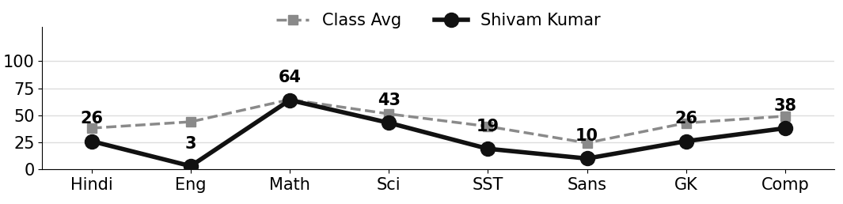
Class Teacher |  | —— Better Education ★ Brighter Future —— |  | Principal

UNIQUE CENTRAL SCHOOL
KNOWLEDGE ★ CHARACTER ★ PROGRESS
ACADEMIC SESSION : 2025 – 2026
RESULT / MARKSHEET
(P.T.1 – 40 | P.T..2 – 40 | S.A.-1 – 80 | Total – 100)

Class : II | Section : B | Roll No. : 22

Student Information  Student Name : Nikhil Kumar  Father’s Name : Mr. Indrajeet Kumar  Mother’s Name : Mrs. Khoosboo Devi | PHOTO  (Optional) | Result Summary
  Total Marks : | 377 / 800
  Percentage (%) : | 47.12 %
  Overall Grade : | C2
  Result : | PASS
  Rank : | 14

S.No. | Subject | Internal Assessment |  |  |  | Summative  Assessment I  (80 marks) | Total  (100 marks) | Grade
S.No. | Subject | P.T. I | P.T. II | Multiple Assessment | Subject Enrichment | Summative  Assessment I  (80 marks) | Total  (100 marks) | Grade
S.No. | Subject | (5 marks) | (5 marks) | (5 marks) | (5 marks) | Summative  Assessment I  (80 marks) | Total  (100 marks) | Grade
1 | Hindi | 4 | 2 | 2 | 2 | 28 | 38 | D
2 | English | 2 | 4 | 3 | 3 | 43 | 55 | C1
3 | Maths | 3 | 5 | 4 | 4 | 65 | 81 | A2
4 | Science | 1 | 1 | 2 | 2 | 48 | 54 | C1
5 | Social Sc. | 2 | 3 | 2 | 2 | 25 | 34 | D
6 | Sans. / Urdu | 3 | 0 | 1 | 1 | 23 | 28 | E
7 | G.K. | 3 | 3 | 3 | 3 | 44 | 56 | C1
8 | Computer | 1 | 5 | 2 | 2 | 21 | 31 | D

CO-SCHOLASTIC AREAS |  |  |  |  |  |  | SCALE
Subject | Drawing | Music | Uniform | Sports | Discipline |  | GRADE | A1 | A2 | B1 | B2 | C1 | C2 | D | E
Grade | B | B | A | B | A |  | MARKS RANGE | 91-100 | 81-90 | 71-80 | 61-70 | 51-60 | 41-50 | 31-40 | Below 30
 |  |  |  |  |  |  | CO-SCH. AREAS | GRADE A  Outstanding |  | GRADE B  Very Good |  | GRADE C  Fair

Attendance  Working Days : 132  Present : 118  Absent : 14 | Teacher’s Remark  Good effort by Nikhil. Needs regular practice to reach  a higher level. Give more time to Sanskrit. |  | Performance Chart (Total /100 : Student vs Class Average)  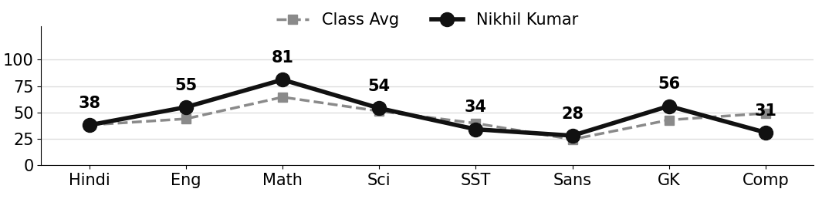
Class Teacher |  | —— Better Education ★ Brighter Future —— |  | Principal

UNIQUE CENTRAL SCHOOL
KNOWLEDGE ★ CHARACTER ★ PROGRESS
ACADEMIC SESSION : 2025 – 2026
RESULT / MARKSHEET
(P.T.1 – 40 | P.T..2 – 40 | S.A.-1 – 80 | Total – 100)

Class : II | Section : B | Roll No. : 23

Student Information  Student Name : Aryan Kumar  Father’s Name : Mr. Ravindra Kumar  Mother’s Name : Mrs. Kushum Devi | PHOTO  (Optional) | Result Summary
  Total Marks : | 0 / 800
  Percentage (%) : | 0.00 %
  Overall Grade : | E
  Result : | FAIL
  Rank : | 31

S.No. | Subject | Internal Assessment |  |  |  | Summative  Assessment I  (80 marks) | Total  (100 marks) | Grade
S.No. | Subject | P.T. I | P.T. II | Multiple Assessment | Subject Enrichment | Summative  Assessment I  (80 marks) | Total  (100 marks) | Grade
S.No. | Subject | (5 marks) | (5 marks) | (5 marks) | (5 marks) | Summative  Assessment I  (80 marks) | Total  (100 marks) | Grade
1 | Hindi | 0 | 0 | 0 | 0 | 0 | 0 | E
2 | English | 0 | 0 | 0 | 0 | 0 | 0 | E
3 | Maths | 0 | 0 | 0 | 0 | 0 | 0 | E
4 | Science | 0 | 0 | 0 | 0 | 0 | 0 | E
5 | Social Sc. | 0 | 0 | 0 | 0 | 0 | 0 | E
6 | Sans. / Urdu | 0 | 0 | 0 | 0 | 0 | 0 | E
7 | G.K. | 0 | 0 | 0 | 0 | 0 | 0 | E
8 | Computer | 0 | 0 | 0 | 0 | 0 | 0 | E

CO-SCHOLASTIC AREAS |  |  |  |  |  |  | SCALE
Subject | Drawing | Music | Uniform | Sports | Discipline |  | GRADE | A1 | A2 | B1 | B2 | C1 | C2 | D | E
Grade | — | — | — | — | — |  | MARKS RANGE | 91-100 | 81-90 | 71-80 | 61-70 | 51-60 | 41-50 | 31-40 | Below 30
 |  |  |  |  |  |  | CO-SCH. AREAS | GRADE A  Outstanding |  | GRADE B  Very Good |  | GRADE C  Fair

Attendance  Working Days : 132  Present : —  Absent : — | Teacher’s Remark  Aryan was not present for the examinations. Regular  attendance is required. |  | Performance Chart (Total /100 : Student vs Class Average)
Class Teacher |  | —— Better Education ★ Brighter Future —— |  | Principal

UNIQUE CENTRAL SCHOOL
KNOWLEDGE ★ CHARACTER ★ PROGRESS
ACADEMIC SESSION : 2025 – 2026
RESULT / MARKSHEET
(P.T.1 – 40 | P.T..2 – 40 | S.A.-1 – 80 | Total – 100)

Class : II | Section : B | Roll No. : 24

Student Information  Student Name : Priti Kumari  Father’s Name : Mr. Sanjeet Kumar  Mother’s Name : Mrs. Anju Devi | PHOTO  (Optional) | Result Summary
  Total Marks : | 178 / 800
  Percentage (%) : | 22.25 %
  Overall Grade : | E
  Result : | FAIL
  Rank : | 28

S.No. | Subject | Internal Assessment |  |  |  | Summative  Assessment I  (80 marks) | Total  (100 marks) | Grade
S.No. | Subject | P.T. I | P.T. II | Multiple Assessment | Subject Enrichment | Summative  Assessment I  (80 marks) | Total  (100 marks) | Grade
S.No. | Subject | (5 marks) | (5 marks) | (5 marks) | (5 marks) | Summative  Assessment I  (80 marks) | Total  (100 marks) | Grade
1 | Hindi | 2 | 2 | 1 | 1 | 5 | 11 | E
2 | English | 0 | 1 | 1 | 1 | 0 | 3 | E
3 | Maths | 3 | 4 | 3 | 2 | 32 | 44 | C2
4 | Science | 0 | 1 | 1 | 1 | 30 | 33 | D
5 | Social Sc. | 2 | 2 | 2 | 1 | 19 | 26 | E
6 | Sans. / Urdu | 0 | 1 | 1 | 1 | 1 | 4 | E
7 | G.K. | 0 | 0 | 1 | 1 | 6 | 8 | E
8 | Computer | 1 | 3 | 2 | 2 | 41 | 49 | C2

CO-SCHOLASTIC AREAS |  |  |  |  |  |  | SCALE
Subject | Drawing | Music | Uniform | Sports | Discipline |  | GRADE | A1 | A2 | B1 | B2 | C1 | C2 | D | E
Grade | C | C | B | C | B |  | MARKS RANGE | 91-100 | 81-90 | 71-80 | 61-70 | 51-60 | 41-50 | 31-40 | Below 30
 |  |  |  |  |  |  | CO-SCH. AREAS | GRADE A  Outstanding |  | GRADE B  Very Good |  | GRADE C  Fair

Attendance  Working Days : 132  Present : 113  Absent : 19 | Teacher’s Remark  Priti needs special attention and regular practice in  all subjects. Regular attendance is required. |  | Performance Chart (Total /100 : Student vs Class Average)  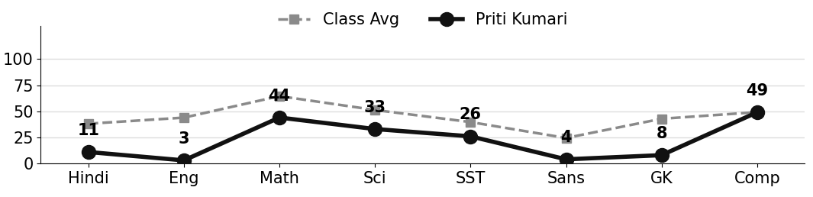
Class Teacher |  | —— Better Education ★ Brighter Future —— |  | Principal

UNIQUE CENTRAL SCHOOL
KNOWLEDGE ★ CHARACTER ★ PROGRESS
ACADEMIC SESSION : 2025 – 2026
RESULT / MARKSHEET
(P.T.1 – 40 | P.T..2 – 40 | S.A.-1 – 80 | Total – 100)

Class : II | Section : B | Roll No. : 25

Student Information  Student Name : Ayush Kumar  Father’s Name : Mr. Ranjeet Prasad  Mother’s Name : Mrs. Pinki Devi | PHOTO  (Optional) | Result Summary
  Total Marks : | 354 / 800
  Percentage (%) : | 44.25 %
  Overall Grade : | C2
  Result : | PASS
  Rank : | 15

S.No. | Subject | Internal Assessment |  |  |  | Summative  Assessment I  (80 marks) | Total  (100 marks) | Grade
S.No. | Subject | P.T. I | P.T. II | Multiple Assessment | Subject Enrichment | Summative  Assessment I  (80 marks) | Total  (100 marks) | Grade
S.No. | Subject | (5 marks) | (5 marks) | (5 marks) | (5 marks) | Summative  Assessment I  (80 marks) | Total  (100 marks) | Grade
1 | Hindi | 3 | 2 | 2 | 2 | 22 | 31 | D
2 | English | 1 | 2 | 1 | 1 | 19 | 24 | E
3 | Maths | 3 | 4 | 4 | 4 | 72 | 87 | A2
4 | Science | 1 | 2 | 2 | 2 | 41 | 48 | C2
5 | Social Sc. | 1 | 3 | 3 | 3 | 60 | 70 | B2
6 | Sans. / Urdu | 1 | 3 | 1 | 1 | 9 | 15 | E
7 | G.K. | 0 | 4 | 2 | 1 | 18 | 25 | E
8 | Computer | 2 | 2 | 2 | 3 | 45 | 54 | C1

CO-SCHOLASTIC AREAS |  |  |  |  |  |  | SCALE
Subject | Drawing | Music | Uniform | Sports | Discipline |  | GRADE | A1 | A2 | B1 | B2 | C1 | C2 | D | E
Grade | C | C | B | B | B |  | MARKS RANGE | 91-100 | 81-90 | 71-80 | 61-70 | 51-60 | 41-50 | 31-40 | Below 30
 |  |  |  |  |  |  | CO-SCH. AREAS | GRADE A  Outstanding |  | GRADE B  Very Good |  | GRADE C  Fair

Attendance  Working Days : 132  Present : 108  Absent : 24 | Teacher’s Remark  Good effort by Ayush. Needs regular practice to reach  a higher level. Give more time to Sanskrit. |  | Performance Chart (Total /100 : Student vs Class Average)  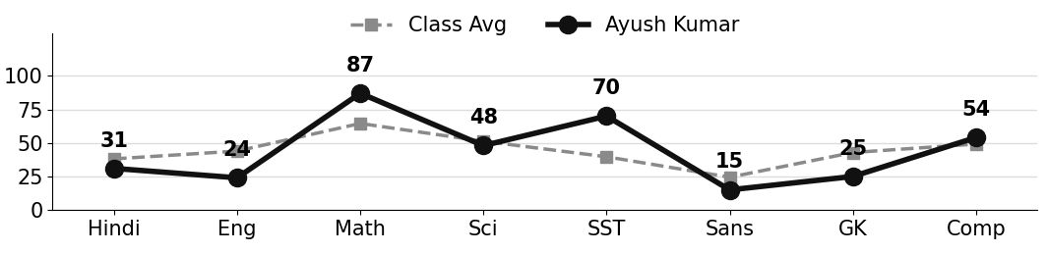
Class Teacher |  | —— Better Education ★ Brighter Future —— |  | Principal

UNIQUE CENTRAL SCHOOL
KNOWLEDGE ★ CHARACTER ★ PROGRESS
ACADEMIC SESSION : 2025 – 2026
RESULT / MARKSHEET
(P.T.1 – 40 | P.T..2 – 40 | S.A.-1 – 80 | Total – 100)

Class : II | Section : B | Roll No. : 26

Student Information  Student Name : Himanshu Kumar  Father’s Name : Mr. Chunnu Kumar  Mother’s Name : Mrs. Pooja Devi | PHOTO  (Optional) | Result Summary
  Total Marks : | 304 / 800
  Percentage (%) : | 38.00 %
  Overall Grade : | D
  Result : | PASS
  Rank : | 20

S.No. | Subject | Internal Assessment |  |  |  | Summative  Assessment I  (80 marks) | Total  (100 marks) | Grade
S.No. | Subject | P.T. I | P.T. II | Multiple Assessment | Subject Enrichment | Summative  Assessment I  (80 marks) | Total  (100 marks) | Grade
S.No. | Subject | (5 marks) | (5 marks) | (5 marks) | (5 marks) | Summative  Assessment I  (80 marks) | Total  (100 marks) | Grade
1 | Hindi | 0 | 3 | 2 | 2 | 35 | 42 | C2
2 | English | 0 | 3 | 2 | 2 | 28 | 35 | D
3 | Maths | 3 | 5 | 3 | 3 | 38 | 52 | C1
4 | Science | 1 | 3 | 2 | 3 | 44 | 53 | C1
5 | Social Sc. | 2 | 3 | 2 | 2 | 25 | 34 | D
6 | Sans. / Urdu | 1 | 2 | 1 | 1 | 7 | 12 | E
7 | G.K. | 0 | 4 | 2 | 2 | 21 | 29 | E
8 | Computer | 0 | 5 | 2 | 2 | 38 | 47 | C2

CO-SCHOLASTIC AREAS |  |  |  |  |  |  | SCALE
Subject | Drawing | Music | Uniform | Sports | Discipline |  | GRADE | A1 | A2 | B1 | B2 | C1 | C2 | D | E
Grade | C | C | B | C | B |  | MARKS RANGE | 91-100 | 81-90 | 71-80 | 61-70 | 51-60 | 41-50 | 31-40 | Below 30
 |  |  |  |  |  |  | CO-SCH. AREAS | GRADE A  Outstanding |  | GRADE B  Very Good |  | GRADE C  Fair

Attendance  Working Days : 132  Present : 105  Absent : 27 | Teacher’s Remark  Himanshu is making steady effort but needs more  practice and regular revision. Give more time to  Sanskrit. |  | Performance Chart (Total /100 : Student vs Class Average)  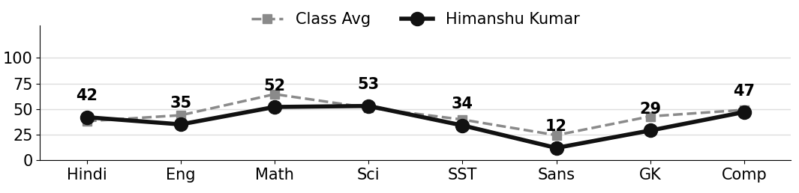
Class Teacher |  | —— Better Education ★ Brighter Future —— |  | Principal

UNIQUE CENTRAL SCHOOL
KNOWLEDGE ★ CHARACTER ★ PROGRESS
ACADEMIC SESSION : 2025 – 2026
RESULT / MARKSHEET
(P.T.1 – 40 | P.T..2 – 40 | S.A.-1 – 80 | Total – 100)

Class : II | Section : B | Roll No. : 27

Student Information  Student Name : Vishal Kumar  Father’s Name : Mr. Shishupal Kumar  Mother’s Name : Mrs. Reena Devi | PHOTO  (Optional) | Result Summary
  Total Marks : | 254 / 800
  Percentage (%) : | 31.75 %
  Overall Grade : | D
  Result : | PASS
  Rank : | 22

S.No. | Subject | Internal Assessment |  |  |  | Summative  Assessment I  (80 marks) | Total  (100 marks) | Grade
S.No. | Subject | P.T. I | P.T. II | Multiple Assessment | Subject Enrichment | Summative  Assessment I  (80 marks) | Total  (100 marks) | Grade
S.No. | Subject | (5 marks) | (5 marks) | (5 marks) | (5 marks) | Summative  Assessment I  (80 marks) | Total  (100 marks) | Grade
1 | Hindi | 3 | 2 | 2 | 1 | 15 | 23 | E
2 | English | 0 | 0 | 1 | 1 | 29 | 31 | D
3 | Maths | 2 | 2 | 2 | 2 | 43 | 51 | C1
4 | Science | 1 | 1 | 1 | 2 | 30 | 35 | D
5 | Social Sc. | 1 | 1 | 1 | 1 | 21 | 25 | E
6 | Sans. / Urdu | 1 | 0 | 1 | 1 | 0 | 3 | E
7 | G.K. | 0 | 3 | 2 | 2 | 25 | 32 | D
8 | Computer | 2 | 3 | 3 | 3 | 43 | 54 | C1

CO-SCHOLASTIC AREAS |  |  |  |  |  |  | SCALE
Subject | Drawing | Music | Uniform | Sports | Discipline |  | GRADE | A1 | A2 | B1 | B2 | C1 | C2 | D | E
Grade | C | C | C | C | C |  | MARKS RANGE | 91-100 | 81-90 | 71-80 | 61-70 | 51-60 | 41-50 | 31-40 | Below 30
 |  |  |  |  |  |  | CO-SCH. AREAS | GRADE A  Outstanding |  | GRADE B  Very Good |  | GRADE C  Fair

Attendance  Working Days : 132  Present : 98  Absent : 34 | Teacher’s Remark  Vishal is making steady effort but needs more practice  and regular revision. Give more time to Sanskrit. |  | Performance Chart (Total /100 : Student vs Class Average)  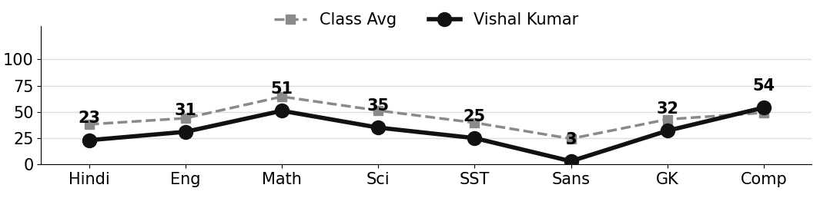
Class Teacher |  | —— Better Education ★ Brighter Future —— |  | Principal

UNIQUE CENTRAL SCHOOL
KNOWLEDGE ★ CHARACTER ★ PROGRESS
ACADEMIC SESSION : 2025 – 2026
RESULT / MARKSHEET
(P.T.1 – 40 | P.T..2 – 40 | S.A.-1 – 80 | Total – 100)

Class : II | Section : B | Roll No. : 28

Student Information  Student Name : Shivraj Kumar  Father’s Name : Mr. Dharmendra Kumar  Mother’s Name : Mrs. Sonam Kumari | PHOTO  (Optional) | Result Summary
  Total Marks : | 247 / 800
  Percentage (%) : | 30.88 %
  Overall Grade : | E
  Result : | PASS
  Rank : | 23

S.No. | Subject | Internal Assessment |  |  |  | Summative  Assessment I  (80 marks) | Total  (100 marks) | Grade
S.No. | Subject | P.T. I | P.T. II | Multiple Assessment | Subject Enrichment | Summative  Assessment I  (80 marks) | Total  (100 marks) | Grade
S.No. | Subject | (5 marks) | (5 marks) | (5 marks) | (5 marks) | Summative  Assessment I  (80 marks) | Total  (100 marks) | Grade
1 | Hindi | 4 | 2 | 2 | 2 | 20 | 30 | E
2 | English | 1 | 5 | 2 | 2 | 20 | 30 | E
3 | Maths | 1 | 3 | 2 | 2 | 32 | 40 | D
4 | Science | 1 | 1 | 2 | 2 | 38 | 44 | C2
5 | Social Sc. | 2 | 1 | 1 | 1 | 14 | 19 | E
6 | Sans. / Urdu | 1 | 3 | 1 | 1 | 7 | 13 | E
7 | G.K. | 0 | 5 | 2 | 1 | 14 | 22 | E
8 | Computer | 2 | 5 | 3 | 3 | 36 | 49 | C2

CO-SCHOLASTIC AREAS |  |  |  |  |  |  | SCALE
Subject | Drawing | Music | Uniform | Sports | Discipline |  | GRADE | A1 | A2 | B1 | B2 | C1 | C2 | D | E
Grade | C | C | B | C | B |  | MARKS RANGE | 91-100 | 81-90 | 71-80 | 61-70 | 51-60 | 41-50 | 31-40 | Below 30
 |  |  |  |  |  |  | CO-SCH. AREAS | GRADE A  Outstanding |  | GRADE B  Very Good |  | GRADE C  Fair

Attendance  Working Days : 132  Present : 102  Absent : 30 | Teacher’s Remark  Shivraj is making steady effort but needs more  practice and regular revision. Give more time to  Sanskrit. |  | Performance Chart (Total /100 : Student vs Class Average)  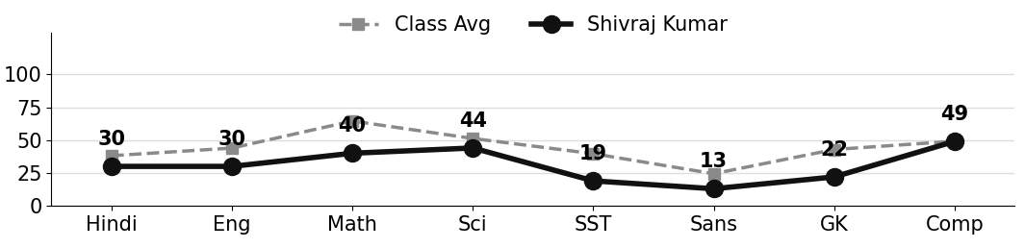
Class Teacher |  | —— Better Education ★ Brighter Future —— |  | Principal

UNIQUE CENTRAL SCHOOL
KNOWLEDGE ★ CHARACTER ★ PROGRESS
ACADEMIC SESSION : 2025 – 2026
RESULT / MARKSHEET
(P.T.1 – 40 | P.T..2 – 40 | S.A.-1 – 80 | Total – 100)

Class : II | Section : B | Roll No. : 29

Student Information  Student Name : Priyanka Kumari  Father’s Name : Mr. Santosh Prasad Keshari  Mother’s Name : Mrs. Khusboo Devi | PHOTO  (Optional) | Result Summary
  Total Marks : | 0 / 800
  Percentage (%) : | 0.00 %
  Overall Grade : | E
  Result : | FAIL
  Rank : | 31

S.No. | Subject | Internal Assessment |  |  |  | Summative  Assessment I  (80 marks) | Total  (100 marks) | Grade
S.No. | Subject | P.T. I | P.T. II | Multiple Assessment | Subject Enrichment | Summative  Assessment I  (80 marks) | Total  (100 marks) | Grade
S.No. | Subject | (5 marks) | (5 marks) | (5 marks) | (5 marks) | Summative  Assessment I  (80 marks) | Total  (100 marks) | Grade
1 | Hindi | 0 | 0 | 0 | 0 | 0 | 0 | E
2 | English | 0 | 0 | 0 | 0 | 0 | 0 | E
3 | Maths | 0 | 0 | 0 | 0 | 0 | 0 | E
4 | Science | 0 | 0 | 0 | 0 | 0 | 0 | E
5 | Social Sc. | 0 | 0 | 0 | 0 | 0 | 0 | E
6 | Sans. / Urdu | 0 | 0 | 0 | 0 | 0 | 0 | E
7 | G.K. | 0 | 0 | 0 | 0 | 0 | 0 | E
8 | Computer | 0 | 0 | 0 | 0 | 0 | 0 | E

CO-SCHOLASTIC AREAS |  |  |  |  |  |  | SCALE
Subject | Drawing | Music | Uniform | Sports | Discipline |  | GRADE | A1 | A2 | B1 | B2 | C1 | C2 | D | E
Grade | — | — | — | — | — |  | MARKS RANGE | 91-100 | 81-90 | 71-80 | 61-70 | 51-60 | 41-50 | 31-40 | Below 30
 |  |  |  |  |  |  | CO-SCH. AREAS | GRADE A  Outstanding |  | GRADE B  Very Good |  | GRADE C  Fair

Attendance  Working Days : 132  Present : —  Absent : — | Teacher’s Remark  Priyanka was not present for the examinations. Regular  attendance is required. |  | Performance Chart (Total /100 : Student vs Class Average)
Class Teacher |  | —— Better Education ★ Brighter Future —— |  | Principal

UNIQUE CENTRAL SCHOOL
KNOWLEDGE ★ CHARACTER ★ PROGRESS
ACADEMIC SESSION : 2025 – 2026
RESULT / MARKSHEET
(P.T.1 – 40 | P.T..2 – 40 | S.A.-1 – 80 | Total – 100)

Class : II | Section : B | Roll No. : 30

Student Information  Student Name : Anjel Kumar  Father’s Name : Mr. Rajesh Saw  Mother’s Name : Mrs. Geeta Devi | PHOTO  (Optional) | Result Summary
  Total Marks : | 308 / 800
  Percentage (%) : | 38.50 %
  Overall Grade : | D
  Result : | PASS
  Rank : | 19

S.No. | Subject | Internal Assessment |  |  |  | Summative  Assessment I  (80 marks) | Total  (100 marks) | Grade
S.No. | Subject | P.T. I | P.T. II | Multiple Assessment | Subject Enrichment | Summative  Assessment I  (80 marks) | Total  (100 marks) | Grade
S.No. | Subject | (5 marks) | (5 marks) | (5 marks) | (5 marks) | Summative  Assessment I  (80 marks) | Total  (100 marks) | Grade
1 | Hindi | 2 | 0 | 1 | 1 | 20 | 24 | E
2 | English | 4 | 1 | 2 | 1 | 9 | 17 | E
3 | Maths | 2 | 2 | 3 | 4 | 74 | 85 | A2
4 | Science | 1 | 3 | 3 | 3 | 50 | 60 | C1
5 | Social Sc. | 1 | 2 | 2 | 2 | 38 | 45 | C2
6 | Sans. / Urdu | 1 | 1 | 1 | 1 | 2 | 6 | E
7 | G.K. | 3 | 0 | 1 | 1 | 16 | 21 | E
8 | Computer | 1 | 0 | 2 | 2 | 45 | 50 | C2

CO-SCHOLASTIC AREAS |  |  |  |  |  |  | SCALE
Subject | Drawing | Music | Uniform | Sports | Discipline |  | GRADE | A1 | A2 | B1 | B2 | C1 | C2 | D | E
Grade | C | C | C | C | C |  | MARKS RANGE | 91-100 | 81-90 | 71-80 | 61-70 | 51-60 | 41-50 | 31-40 | Below 30
 |  |  |  |  |  |  | CO-SCH. AREAS | GRADE A  Outstanding |  | GRADE B  Very Good |  | GRADE C  Fair

Attendance  Working Days : 132  Present : 97  Absent : 35 | Teacher’s Remark  Anjel is making steady effort but needs more practice  and regular revision. Give more time to Sanskrit. |  | Performance Chart (Total /100 : Student vs Class Average)  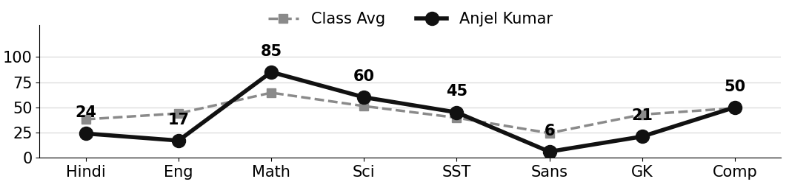
Class Teacher |  | —— Better Education ★ Brighter Future —— |  | Principal

UNIQUE CENTRAL SCHOOL
KNOWLEDGE ★ CHARACTER ★ PROGRESS
ACADEMIC SESSION : 2025 – 2026
RESULT / MARKSHEET
(P.T.1 – 40 | P.T..2 – 40 | S.A.-1 – 80 | Total – 100)

Class : II | Section : B | Roll No. : 31

Student Information  Student Name : Dhiraj Kumar  Father’s Name : Mr. Arvind Yadav  Mother’s Name : Mrs. Sarita Devi | PHOTO  (Optional) | Result Summary
  Total Marks : | 63 / 800
  Percentage (%) : | 7.88 %
  Overall Grade : | E
  Result : | FAIL
  Rank : | 30

S.No. | Subject | Internal Assessment |  |  |  | Summative  Assessment I  (80 marks) | Total  (100 marks) | Grade
S.No. | Subject | P.T. I | P.T. II | Multiple Assessment | Subject Enrichment | Summative  Assessment I  (80 marks) | Total  (100 marks) | Grade
S.No. | Subject | (5 marks) | (5 marks) | (5 marks) | (5 marks) | Summative  Assessment I  (80 marks) | Total  (100 marks) | Grade
1 | Hindi | 2 | 0 | 1 | 1 | 15 | 19 | E
2 | English | 0 | 0 | 1 | 1 | 2 | 4 | E
3 | Maths | 3 | 0 | 1 | 1 | 0 | 5 | E
4 | Science | 2 | 0 | 1 | 1 | 0 | 4 | E
5 | Social Sc. | 0 | 0 | 0 | 0 | 0 | 0 | E
6 | Sans. / Urdu | 1 | 0 | 1 | 1 | 0 | 3 | E
7 | G.K. | 0 | 0 | 1 | 1 | 4 | 6 | E
8 | Computer | 0 | 0 | 1 | 1 | 20 | 22 | E

CO-SCHOLASTIC AREAS |  |  |  |  |  |  | SCALE
Subject | Drawing | Music | Uniform | Sports | Discipline |  | GRADE | A1 | A2 | B1 | B2 | C1 | C2 | D | E
Grade | C | C | C | C | C |  | MARKS RANGE | 91-100 | 81-90 | 71-80 | 61-70 | 51-60 | 41-50 | 31-40 | Below 30
 |  |  |  |  |  |  | CO-SCH. AREAS | GRADE A  Outstanding |  | GRADE B  Very Good |  | GRADE C  Fair

Attendance  Working Days : 132  Present : 62  Absent : 70 | Teacher’s Remark  Dhiraj needs special attention and regular practice in  all subjects. Regular attendance is required. |  | Performance Chart (Total /100 : Student vs Class Average)  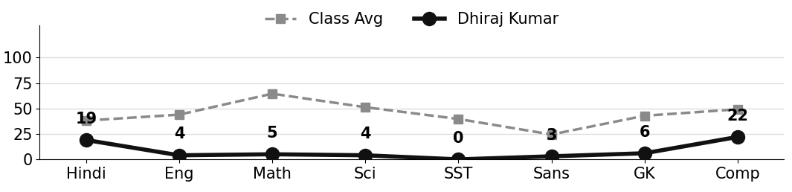
Class Teacher |  | —— Better Education ★ Brighter Future —— |  | Principal

UNIQUE CENTRAL SCHOOL
KNOWLEDGE ★ CHARACTER ★ PROGRESS
ACADEMIC SESSION : 2025 – 2026
RESULT / MARKSHEET
(P.T.1 – 40 | P.T..2 – 40 | S.A.-1 – 80 | Total – 100)

Class : II | Section : B | Roll No. : 32

Student Information  Student Name : Sneha Kumari  Father’s Name : Mr. Ranjeet Kumar  Mother’s Name : Mrs. Pinki Devi | PHOTO  (Optional) | Result Summary
  Total Marks : | 191 / 800
  Percentage (%) : | 23.88 %
  Overall Grade : | E
  Result : | FAIL
  Rank : | 26

S.No. | Subject | Internal Assessment |  |  |  | Summative  Assessment I  (80 marks) | Total  (100 marks) | Grade
S.No. | Subject | P.T. I | P.T. II | Multiple Assessment | Subject Enrichment | Summative  Assessment I  (80 marks) | Total  (100 marks) | Grade
S.No. | Subject | (5 marks) | (5 marks) | (5 marks) | (5 marks) | Summative  Assessment I  (80 marks) | Total  (100 marks) | Grade
1 | Hindi | 2 | 2 | 1 | 1 | 15 | 21 | E
2 | English | 0 | 3 | 1 | 1 | 6 | 11 | E
3 | Maths | 4 | 3 | 3 | 2 | 28 | 40 | D
4 | Science | 0 | 1 | 1 | 1 | 27 | 30 | E
5 | Social Sc. | 1 | 2 | 2 | 2 | 28 | 35 | D
6 | Sans. / Urdu | 0 | 2 | 1 | 1 | 4 | 8 | E
7 | G.K. | 1 | 2 | 1 | 1 | 20 | 25 | E
8 | Computer | 1 | 3 | 1 | 1 | 15 | 21 | E

CO-SCHOLASTIC AREAS |  |  |  |  |  |  | SCALE
Subject | Drawing | Music | Uniform | Sports | Discipline |  | GRADE | A1 | A2 | B1 | B2 | C1 | C2 | D | E
Grade | C | C | B | C | B |  | MARKS RANGE | 91-100 | 81-90 | 71-80 | 61-70 | 51-60 | 41-50 | 31-40 | Below 30
 |  |  |  |  |  |  | CO-SCH. AREAS | GRADE A  Outstanding |  | GRADE B  Very Good |  | GRADE C  Fair

Attendance  Working Days : 132  Present : 109  Absent : 23 | Teacher’s Remark  Sneha needs special attention and regular practice in  all subjects. Regular attendance is required. |  | Performance Chart (Total /100 : Student vs Class Average)  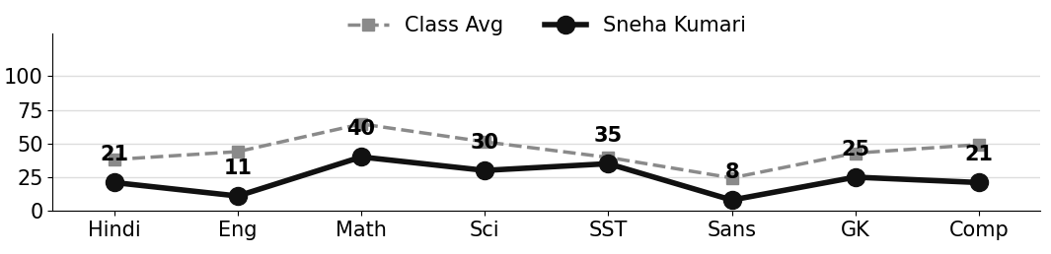
Class Teacher |  | —— Better Education ★ Brighter Future —— |  | Principal

UNIQUE CENTRAL SCHOOL
KNOWLEDGE ★ CHARACTER ★ PROGRESS
ACADEMIC SESSION : 2025 – 2026
RESULT / MARKSHEET
(P.T.1 – 40 | P.T..2 – 40 | S.A.-1 – 80 | Total – 100)

Class : II | Section : B | Roll No. : 33

Student Information  Student Name :  Father’s Name :  Mother’s Name : | PHOTO  (Optional) | Result Summary
  Total Marks :
  Percentage (%) :
  Overall Grade :
  Result :
  Rank :

S.No. | Subject | Internal Assessment |  |  |  | Summative  Assessment I  (80 marks) | Total  (100 marks) | Grade
S.No. | Subject | P.T. I | P.T. II | Multiple Assessment | Subject Enrichment | Summative  Assessment I  (80 marks) | Total  (100 marks) | Grade
S.No. | Subject | (5 marks) | (5 marks) | (5 marks) | (5 marks) | Summative  Assessment I  (80 marks) | Total  (100 marks) | Grade
1 | Hindi
2 | English
3 | Maths
4 | Science
5 | Social Sc.
6 | Sans. / Urdu
7 | G.K.
8 | Computer

CO-SCHOLASTIC AREAS |  |  |  |  |  |  | SCALE
Subject | Drawing | Music | Uniform | Sports | Discipline |  | GRADE | A1 | A2 | B1 | B2 | C1 | C2 | D | E
Grade |  |  |  |  |  |  | MARKS RANGE | 91-100 | 81-90 | 71-80 | 61-70 | 51-60 | 41-50 | 31-40 | Below 30
 |  |  |  |  |  |  | CO-SCH. AREAS | GRADE A  Outstanding |  | GRADE B  Very Good |  | GRADE C  Fair

Attendance  Working Days : 132  Present :  Absent : | Teacher’s Remark |  | Performance Chart (Total /100 : Student vs Class Average)
Class Teacher |  | —— Better Education ★ Brighter Future —— |  | Principal

UNIQUE CENTRAL SCHOOL
KNOWLEDGE ★ CHARACTER ★ PROGRESS
ACADEMIC SESSION : 2025 – 2026
RESULT / MARKSHEET
(P.T.1 – 40 | P.T..2 – 40 | S.A.-1 – 80 | Total – 100)

Class : II | Section : B | Roll No. : 34

Student Information  Student Name : Pren Kumar  Father’s Name : Mr. Pankaj Kumar  Mother’s Name : Mrs. Nishpa Kumari | PHOTO  (Optional) | Result Summary
  Total Marks : | 180 / 800
  Percentage (%) : | 22.50 %
  Overall Grade : | E
  Result : | FAIL
  Rank : | 27

S.No. | Subject | Internal Assessment |  |  |  | Summative  Assessment I  (80 marks) | Total  (100 marks) | Grade
S.No. | Subject | P.T. I | P.T. II | Multiple Assessment | Subject Enrichment | Summative  Assessment I  (80 marks) | Total  (100 marks) | Grade
S.No. | Subject | (5 marks) | (5 marks) | (5 marks) | (5 marks) | Summative  Assessment I  (80 marks) | Total  (100 marks) | Grade
1 | Hindi | 3 | 0 | 1 | 1 | 18 | 23 | E
2 | English | 1 | 0 | 1 | 1 | 30 | 33 | D
3 | Maths | 1 | 2 | 1 | 1 | 23 | 28 | E
4 | Science | 0 | 1 | 1 | 1 | 6 | 9 | E
5 | Social Sc. | 0 | 1 | 1 | 1 | 2 | 5 | E
6 | Sans. / Urdu | 1 | 1 | 1 | 1 | 0 | 4 | E
7 | G.K. | 0 | 0 | 1 | 1 | 20 | 22 | E
8 | Computer | 1 | 0 | 2 | 2 | 51 | 56 | C1

CO-SCHOLASTIC AREAS |  |  |  |  |  |  | SCALE
Subject | Drawing | Music | Uniform | Sports | Discipline |  | GRADE | A1 | A2 | B1 | B2 | C1 | C2 | D | E
Grade | C | C | A | C | B |  | MARKS RANGE | 91-100 | 81-90 | 71-80 | 61-70 | 51-60 | 41-50 | 31-40 | Below 30
 |  |  |  |  |  |  | CO-SCH. AREAS | GRADE A  Outstanding |  | GRADE B  Very Good |  | GRADE C  Fair

Attendance  Working Days : 132  Present : 119  Absent : 13 | Teacher’s Remark  Pren needs special attention and regular practice in  all subjects. Regular attendance is required. |  | Performance Chart (Total /100 : Student vs Class Average)  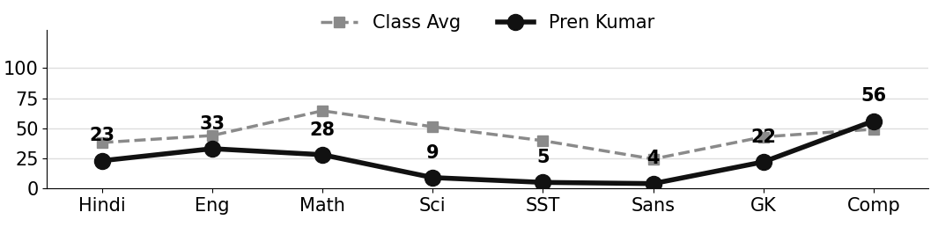
Class Teacher |  | —— Better Education ★ Brighter Future —— |  | Principal

UNIQUE CENTRAL SCHOOL
KNOWLEDGE ★ CHARACTER ★ PROGRESS
ACADEMIC SESSION : 2025 – 2026
RESULT / MARKSHEET
(P.T.1 – 40 | P.T..2 – 40 | S.A.-1 – 80 | Total – 100)

Class : II | Section : B | Roll No. : 35

Student Information  Student Name : Rakhi Kumari  Father’s Name : Mr. Sanjeet Kumar  Mother’s Name : Mrs. Anju Devi | PHOTO  (Optional) | Result Summary
  Total Marks : | 142 / 800
  Percentage (%) : | 17.75 %
  Overall Grade : | E
  Result : | FAIL
  Rank : | 29

S.No. | Subject | Internal Assessment |  |  |  | Summative  Assessment I  (80 marks) | Total  (100 marks) | Grade
S.No. | Subject | P.T. I | P.T. II | Multiple Assessment | Subject Enrichment | Summative  Assessment I  (80 marks) | Total  (100 marks) | Grade
S.No. | Subject | (5 marks) | (5 marks) | (5 marks) | (5 marks) | Summative  Assessment I  (80 marks) | Total  (100 marks) | Grade
1 | Hindi | 1 | 2 | 1 | 1 | 10 | 15 | E
2 | English | 0 | 1 | 1 | 1 | 0 | 3 | E
3 | Maths | 2 | 4 | 2 | 2 | 20 | 30 | E
4 | Science | 1 | 1 | 1 | 1 | 25 | 29 | E
5 | Social Sc. | 1 | 2 | 1 | 1 | 2 | 7 | E
6 | Sans. / Urdu | 1 | 2 | 1 | 1 | 0 | 5 | E
7 | G.K. | 0 | 0 | 1 | 1 | 22 | 24 | E
8 | Computer | 0 | 2 | 1 | 1 | 25 | 29 | E

CO-SCHOLASTIC AREAS |  |  |  |  |  |  | SCALE
Subject | Drawing | Music | Uniform | Sports | Discipline |  | GRADE | A1 | A2 | B1 | B2 | C1 | C2 | D | E
Grade | C | C | B | C | B |  | MARKS RANGE | 91-100 | 81-90 | 71-80 | 61-70 | 51-60 | 41-50 | 31-40 | Below 30
 |  |  |  |  |  |  | CO-SCH. AREAS | GRADE A  Outstanding |  | GRADE B  Very Good |  | GRADE C  Fair

Attendance  Working Days : 132  Present : 107  Absent : 25 | Teacher’s Remark  Rakhi needs special attention and regular practice in  all subjects. Regular attendance is required. |  | Performance Chart (Total /100 : Student vs Class Average)  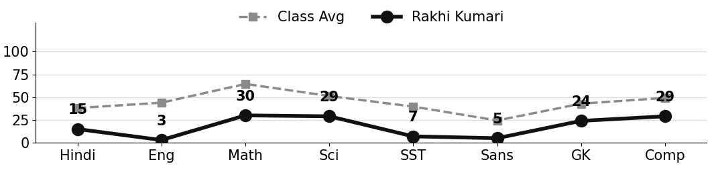
Class Teacher |  | —— Better Education ★ Brighter Future —— |  | Principal

UNIQUE CENTRAL SCHOOL
KNOWLEDGE ★ CHARACTER ★ PROGRESS
ACADEMIC SESSION : 2025 – 2026
RESULT / MARKSHEET
(P.T.1 – 40 | P.T..2 – 40 | S.A.-1 – 80 | Total – 100)

Class : II | Section : B | Roll No. : 36

Student Information  Student Name : Pawan Kumar  Father’s Name : Mr. Kallu Mistri  Mother’s Name : Mrs. Kanchan Devi | PHOTO  (Optional) | Result Summary
  Total Marks : | 234 / 800
  Percentage (%) : | 29.25 %
  Overall Grade : | E
  Result : | FAIL
  Rank : | 24

S.No. | Subject | Internal Assessment |  |  |  | Summative  Assessment I  (80 marks) | Total  (100 marks) | Grade
S.No. | Subject | P.T. I | P.T. II | Multiple Assessment | Subject Enrichment | Summative  Assessment I  (80 marks) | Total  (100 marks) | Grade
S.No. | Subject | (5 marks) | (5 marks) | (5 marks) | (5 marks) | Summative  Assessment I  (80 marks) | Total  (100 marks) | Grade
1 | Hindi | 0 | 2 | 1 | 1 | 18 | 22 | E
2 | English | 1 | 2 | 1 | 1 | 6 | 11 | E
3 | Maths | 1 | 2 | 2 | 2 | 42 | 49 | C2
4 | Science | 1 | 2 | 2 | 2 | 42 | 49 | C2
5 | Social Sc. | 1 | 0 | 1 | 1 | 18 | 21 | E
6 | Sans. / Urdu | 0 | 0 | 1 | 1 | 11 | 13 | E
7 | G.K. | 1 | 2 | 2 | 2 | 40 | 47 | C2
8 | Computer | 0 | 3 | 1 | 1 | 17 | 22 | E

CO-SCHOLASTIC AREAS |  |  |  |  |  |  | SCALE
Subject | Drawing | Music | Uniform | Sports | Discipline |  | GRADE | A1 | A2 | B1 | B2 | C1 | C2 | D | E
Grade | C | C | C | C | C |  | MARKS RANGE | 91-100 | 81-90 | 71-80 | 61-70 | 51-60 | 41-50 | 31-40 | Below 30
 |  |  |  |  |  |  | CO-SCH. AREAS | GRADE A  Outstanding |  | GRADE B  Very Good |  | GRADE C  Fair

Attendance  Working Days : 132  Present : 95  Absent : 37 | Teacher’s Remark  Pawan needs special attention and regular practice in  all subjects. Regular attendance is required. |  | Performance Chart (Total /100 : Student vs Class Average)  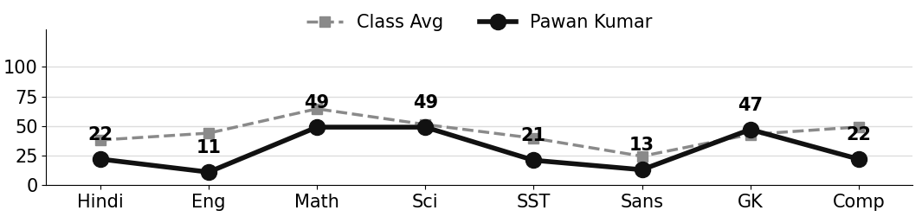
Class Teacher |  | —— Better Education ★ Brighter Future —— |  | Principal

UNIQUE CENTRAL SCHOOL
KNOWLEDGE ★ CHARACTER ★ PROGRESS
ACADEMIC SESSION : 2025 – 2026
RESULT / MARKSHEET
(P.T.1 – 40 | P.T..2 – 40 | S.A.-1 – 80 | Total – 100)

Class : II | Section : B | Roll No. : 37

Student Information  Student Name : Khushi Kumari  Father’s Name : Mr. Ravi Kumar  Mother’s Name : Mrs. Pinki Kumari | PHOTO  (Optional) | Result Summary
  Total Marks :
  Percentage (%) :
  Overall Grade :
  Result :
  Rank :

S.No. | Subject | Internal Assessment |  |  |  | Summative  Assessment I  (80 marks) | Total  (100 marks) | Grade
S.No. | Subject | P.T. I | P.T. II | Multiple Assessment | Subject Enrichment | Summative  Assessment I  (80 marks) | Total  (100 marks) | Grade
S.No. | Subject | (5 marks) | (5 marks) | (5 marks) | (5 marks) | Summative  Assessment I  (80 marks) | Total  (100 marks) | Grade
1 | Hindi
2 | English
3 | Maths
4 | Science
5 | Social Sc.
6 | Sans. / Urdu
7 | G.K.
8 | Computer

CO-SCHOLASTIC AREAS |  |  |  |  |  |  | SCALE
Subject | Drawing | Music | Uniform | Sports | Discipline |  | GRADE | A1 | A2 | B1 | B2 | C1 | C2 | D | E
Grade |  |  |  |  |  |  | MARKS RANGE | 91-100 | 81-90 | 71-80 | 61-70 | 51-60 | 41-50 | 31-40 | Below 30
 |  |  |  |  |  |  | CO-SCH. AREAS | GRADE A  Outstanding |  | GRADE B  Very Good |  | GRADE C  Fair

Attendance  Working Days : 132  Present : 112  Absent : 20 | Teacher’s Remark |  | Performance Chart (Total /100 : Student vs Class Average)
Class Teacher |  | —— Better Education ★ Brighter Future —— |  | Principal

